November 2019

Dates for your Diary
REMINDER: SCHOOL CLOSED WED OCT 23rd for STAFF INSERVICE
Oct 25th: Fundraiser: Pupils may wear Halloween costumes to school. A contribution of €2 is requested to go towards school funds. (Please avoid Clown costumes). There is also a themed fancy dress with spot prizes as part of our Green Schools programme. The theme is “Energy”
Oct 28th – November 1st: Mid-Term Break
Nov 11th - Nov 15th: Science Week
Nov 5th: Parent Association Meeting & nominations for Board of Management (See letter attached) at 8pm.

Attendance
Last September’s attendance rate was 92.8%. Please ensure that if your child is absent to ring the school that morning and explain why your child is out. This should be followed up with a note of explanation on return to school. Also be sure to get your child to school on time. Thank you for your cooperation.
We will be issuing letters to parents where absenteeism and lateness is a concern.
In November to promote good attendance we have set a 20 Day Challenge encouraging all pupils to attend school for all 20 days of November.
We are also running a poster competition entitled “ Every School Day Counts” to raise awareness.

Family Contribution Envelopes
Thank you to all parents who have contributed to our envelope collection thus far. For those who are contributing €5 per month, the next collection date is Wed Nov 6th.

Glor Ceatharlach Art Winner
Well done to Emily Nolan (2nd); our prize winner in the Glor Ceatharlach Art Competition.

Shoebox Appeal
Once again, St. Fiaccs NS will take part in the Team Hope Christmas Shoe Box Appeal. Each child has received a leaflet which includes a list of acceptable items. Shoe boxes plus €4 must be returned to the school before mid term break if possible. This has been a very successful project in our school over the last number of years. We thank you for taking part.

Folens Christmas Annual
We will be issuing order forms for Folens Christmas annuals shortly

ENROLMENTS 2019-2020
St. Fiacc’s is accepting enrolments for Junior Infants (2019). Closing date for receipt of applications is November 8th.

Our new Student Council

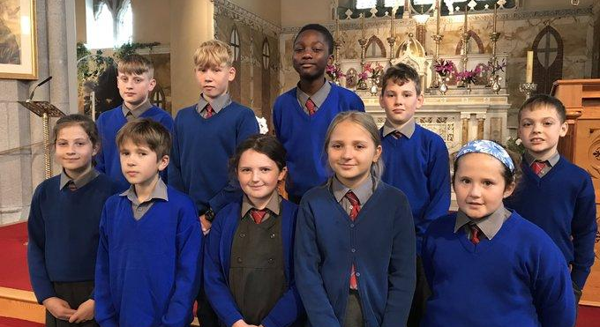

Girls’ Football
Our girls have reached the County Finals of Laois Cumann na mBunscol Girls’ Football. The girls will play Holy Family NS on Thursday Oct 24th at 10.30 at O’ Moore Park (This may change depending on pitch condition). We are extremely proud of our team and wish them all the best. Well done also to Miss Minnock & Miss Ronan for coaching.
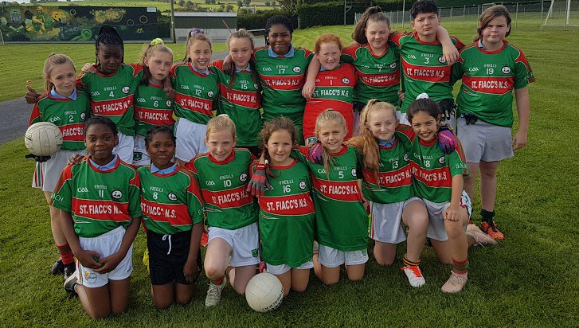

Boys’ Football
Well done to the boys who reached the semifinal of the Shield competition. Here they are pictured with Bennekerry NS after a friendly.

Say No To Racism
Thank you to Gary Coady (FAI) who workshopped this topic with our pupils in October.

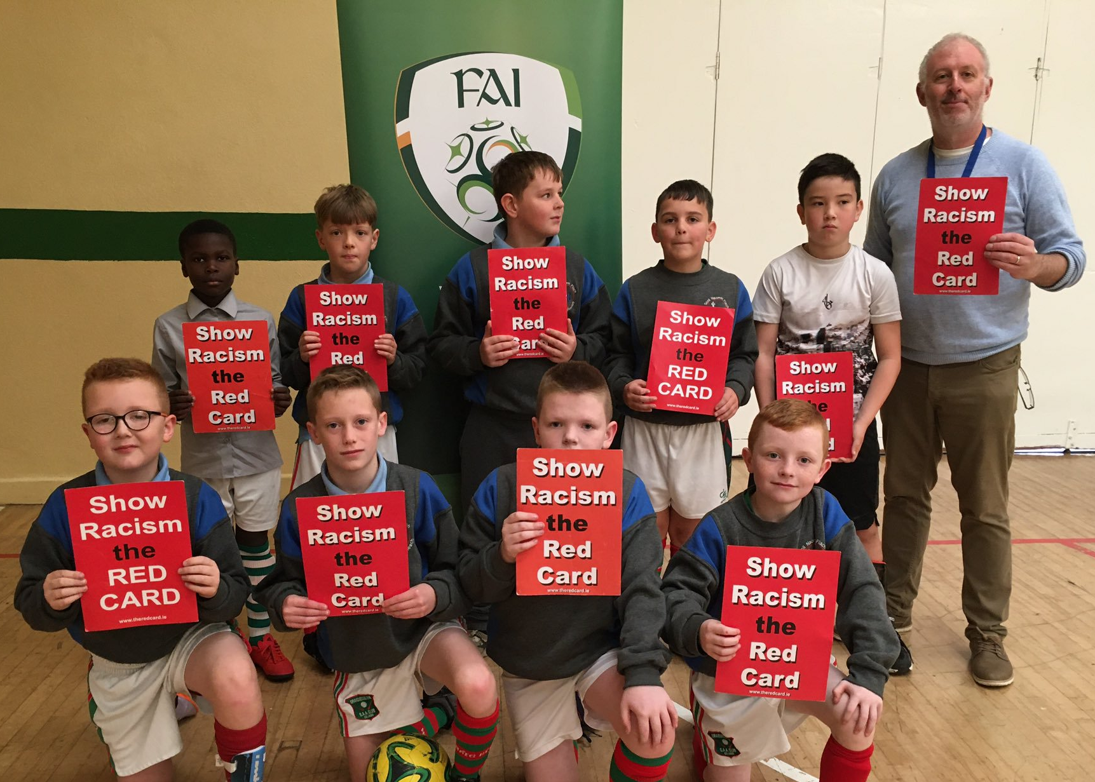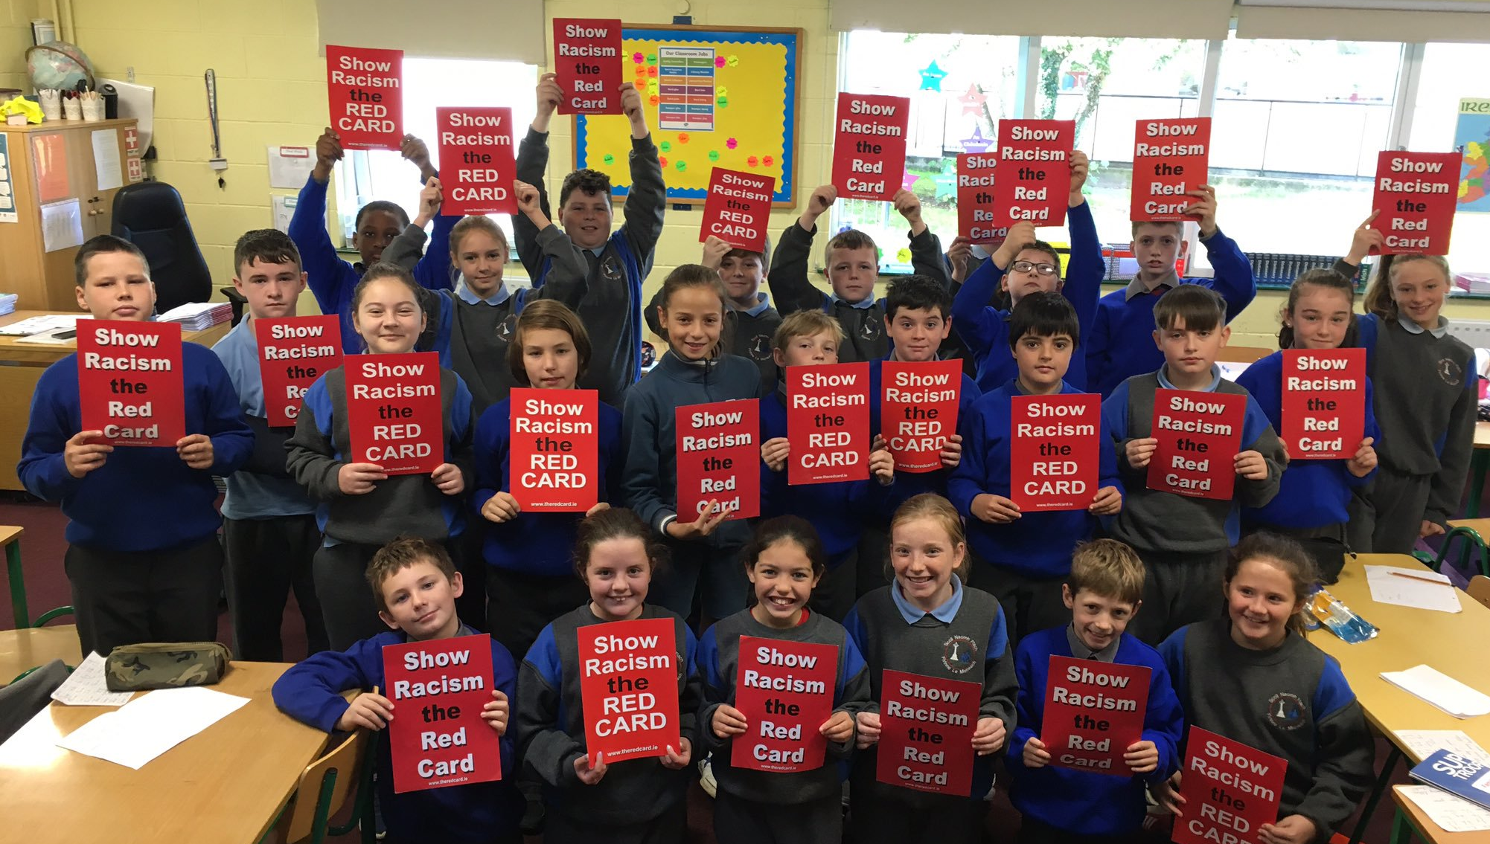

MATHS WEEK OCT 14th - 18th
Some Maths Trails with Miss Davitt’s Class

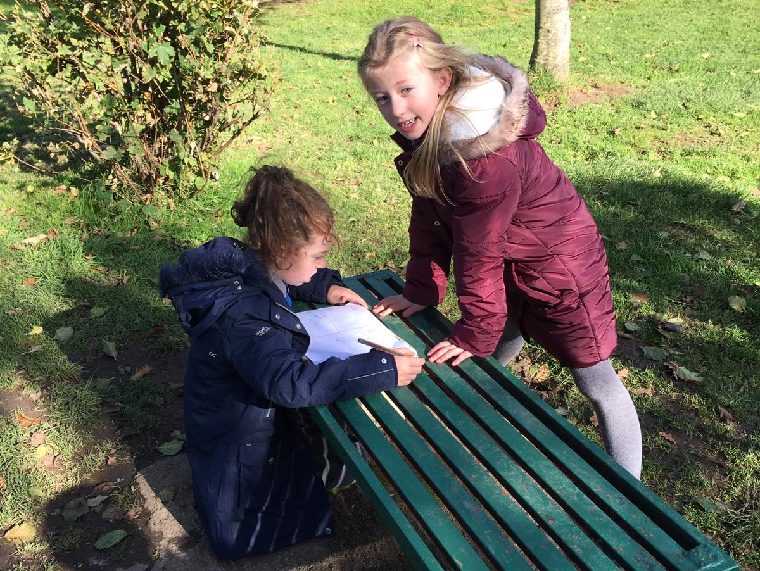

Religious Education
At assembly we have been celebrating October, the month of the Rosary. November is a time when we remember our deceased relatives and friends.

Class outings
Oct 22nd: 6th classes attend “Blood Brothers”
Oct 24th: 6th visit Carlow Military Museum. Cost €4 (This date may change if clashing with Girls’ Final)
Nov 7th: 5th visit Carlow County Museum. Cost €4.
Nov 8th: 3rd class attend “BirdBoy” at Carlow Visual. Cost €3.

Our Debating Team (pictured before their first outing against Green Road)

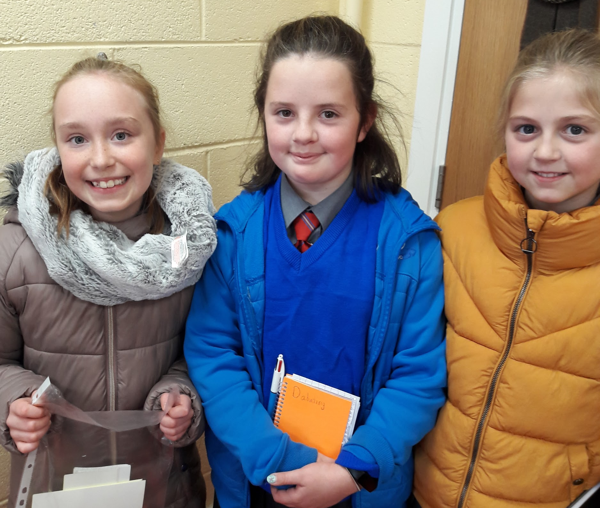

LETTER REGARDING NEW BOARDS OF MANAGEMENT
Dear Parent/guardian,
On 1 December 2019 a new Board of Management will be appointed to every primary school in the country. Boards of Management are appointed for a 4-year term and their task is to manage the school on behalf of our Patron, Bishop Denis Nulty. Each Board of Management has eight members, two of which are Parent Nominees elected from those parents who currently have children enrolled in the school.
Following discussions with the parent nominees currently serving on the Board of Management and our Parent Association it has been decided that the best way to elect Parent Nominees for the new board of our school is at the next Meeting of our Parent Association on Tuesday, November 5th at St. Fiacc’s NS at 8pm.
At this meeting:
- Nominations will be invited for a both a Mother’s Panel and a Father’s Panel
- Parents may nominate themselves, but the nomination must be seconded by someone who is present at the meeting
- If there is only one nominee for either or both Panels the nominee/s will deemed to be elected
- If there is more than one nomination for either or both panels, then a secret ballot will be held. This will happen at the meeting.
- There will be two tellers appointed and the votes will be counted in public
- In the event of a tied vote the election shall be decided by a drawing of lots
A strong and effective Board of Management is essential to providing the best possible education for your child. The parent voice is a very important one on this board and I look forward to seeing as many as possible of you at this meeting.

Kind regards,

________________

John Brennan

