November 2018

Dates for your Diary
Oct 16th – November 27th : Swimming for Mr Kelly (5th) & Miss Walsh (3rd ) – 6 weeks.
Cost €4 per pupil. (Total €24)
Oct 25th: Fundraiser: Pupils may wear Halloween costumes to school. A contribution of €2 is requested to go towards school funds. (Please avoid Clown costumes). There is also a “Global Warming” themed fancy dress with spot prizes as part of our Green Schools programme.
Oct 29th – November 2nd: Mid-Term Break

E-Payments
Our school continues to roll out an ePayment option to parents/guardians of children in our school. The ePayment system will give you access from an internet browser on your computer, phone or tablet to make secure payments to the school using your credit or debit card. The purpose of the ePayment system is to facilitate the easier payment of school money collections for parent/guardians and to reduce the amount of cash and cheques being sent into our school in line with recent central bank directives.

Aladdin Connect
Our school is delighted to announce that we will shortly roll out the Aladdin Schools Connect to parents/guardians of children in our classes.
The school uses the Aladdin Schools software service www.aladdin.ie for administrative purposes and Connect will give you secure access to messages from the school and to details of your child’s attendance, test results, reports cards etc via secure login from your internet browser or Aladdin Connect App. A detailed letter was sent out outlining the benefits in greater detail.

Attendance
Last September’s attendance rate was 94%. Please ensure that if your child is absent to ring the school that morning and explain why your child is out. This should be followed up with a note of explanation on return to school. Also be sure to get your child to school on time. Thank you for your cooperation.

Family Contribution Envelopes
Thank you to all parents who have contributed to our envelope collection thus far. For those who are contributing €5 per month, the next collection date is Wed Nov 7th .

Glor Ceatharlach Art Winner
Well done to Mikey Murnane (2nd class) who was a prize winner in the Glor Ceatharlach Art Competition.

Shoebox Appeal
Once again, St. Fiaccs NS will take part in the Team Hope Christmas Shoe Box Appeal. Each child has received a leaflet which includes a list of the acceptable items. Shoe boxes plus €4 must be returned to the school before mid term break if possible. This has been a very successful project in our school over the last number of years. We thank you for taking part.

Folens Christmas Annual
Please find attached order form for Folens Christmas annuals.
ENROLMENTS 2019-2020
St. Fiacc’s is accepting enrolments for Junior Infants (2019). Closing date for receipt of applications is November 9th.

Child Safeguarding Statement
Please find attached to this newsletter a copy of our Child Safeguarding Statement and Risk Assessment

Our new Student Council

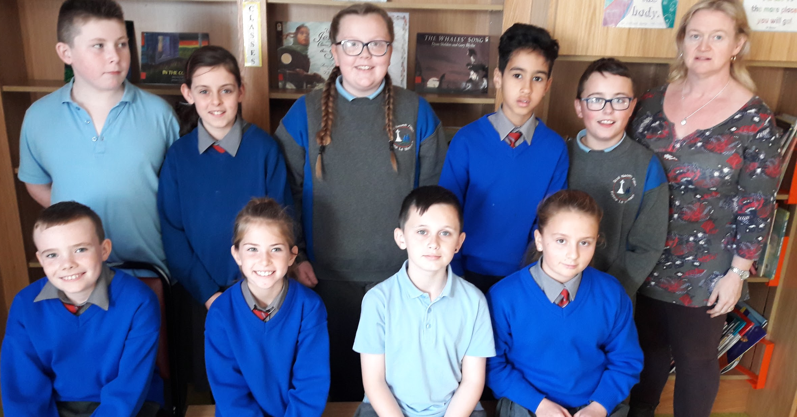
Parking Reminder.
Please do not park across house entrances at any time.
Thank you.

Well done to the the pupils and Green Schools Committee of St. Fiacc’s for their Commendation at last month’s Tidy Towns Awards Ceremony.

School Photographs:
Orders for school photographs for Junior Infants Classes will be collected on Thurs Oct 25th.

Religious Education
At assembly we have been celebrating October, the month of the Rosary. November is a time when we remember our deceased relatives and friends.

