March 2019
Dates for your Diary
March 1st: Entrance Assessments for students commencing Post Primary School September 2019 for Carlow Town schools will take place from 2.00pm - 4.30pm approx.
March 4th - 8th: Engineer’s Week at St. Fiacc’s.
March 19th: St. Fiacc’s will be closed to facilitate Staff Training for the Primary Language Curriculum as sanctioned by the Department of Education.
March 27th: First Confessions - 2nd class.
April 10th: Meeting for parents of next year’s Junior Infants in school hall at 10am.
May 4th: Confirmation - 6th class at 11am.
May 25th: First Holy Communion Masses. (Miss Doheny’s class at 10.30am and Miss Kavanagh & Mr Sheil’s classes at 12.30pm)

Swimming
Swimming for Miss Ivory’s 4th/5th class and Miss Scully’s 3rd class is arranged for the following dates: March 26th; April 2nd; 9th; 29th; May 13th & 20th.

World Book Day March 7th
Please find enclosed a World Book Day token that can be redeemed against the purchase of a book.

Thank you!
To all families returning our family contribution envelope. Date of next contribution: Wed March 6th

Engineer’s Week
To celebrate Engineer’s Week Miss Luby’s; Miss Killeen’s and Miss Ivory’s classes will attend a Science Show in Carlow IT, Tuesday, March 5th. Bus will leave at 9.20 so be on time!! €2 per pupil to cover cost. We will have interesting Science and Maths activities in all classes that week.

If there are any parents who work in Engineering we would love to have you drop into our classes that week?

Grandparents’ Day at St. Fiacc’s
Thanks to all the Grandparents who shared their memories with our boys and girls.

Peace Proms 2019
On Saturday 9th February, our School choir took part in the Peace Proms concert in Waterford IT. They had a memorable experience. Thanks to Miss Kavanagh for organising.

Are you concerned about your child experiencing Anxiety?
Please read flier attached to newsletter and/or attend upcoming talk.

MONDAY 4TH MARCH 2019 @ 6:30PM TO 8:30PM - ST FIACC’S NS GRAIGUECULLEN
FREE TO ATTEND
BOOK YOUR PLACE WITH DEIRDRE: deirdre.dowling@hse.ie
(Contact Sharon at the school if you have no email)

6th class attend a Prayer Service with Bishop Denis on Feb 1st
I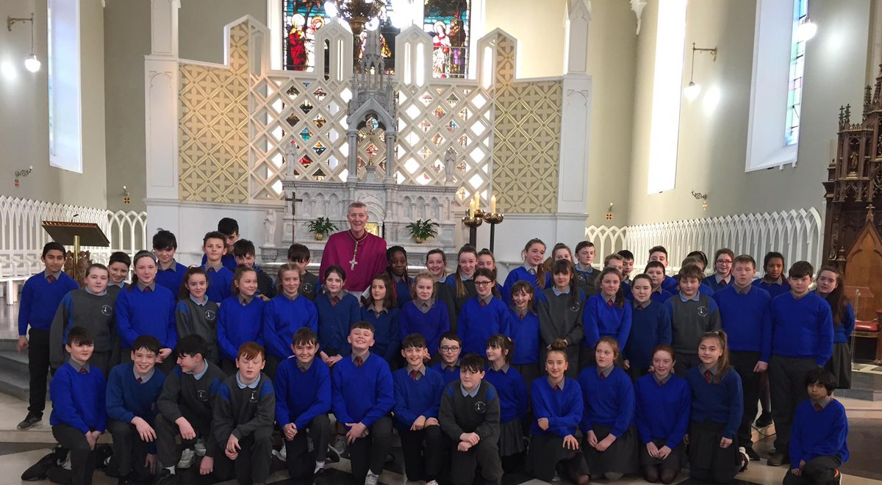

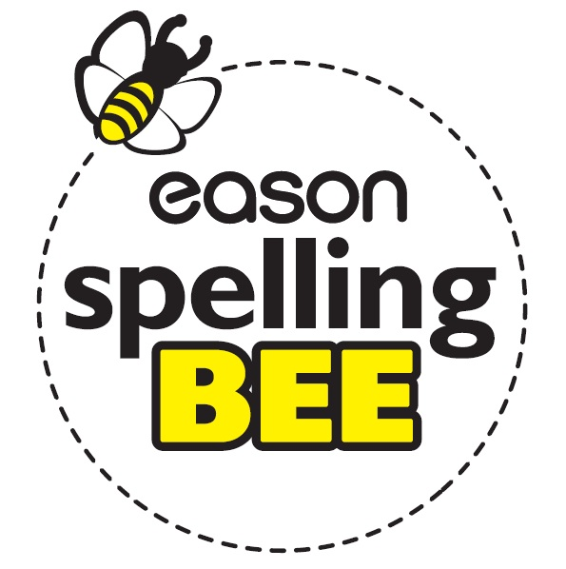
Best of luck to Kate Sheehan who will participate in the Carlow Spelling Bee County Final on February 27th .

Athletics Programme for 5th & 6th
Laois Sports Partnership will provide athletics training to the pupils of 5th & 6th over a four week period on Wednesdays: Feb 27th; March 6th; March 13th and 20th. Pupils will be asked to contribute €3 per session to pay for the bus out to St. Abban’s Hall.

Table Tennis
Table Tennis lessons after school every Wednesday starting Feb 27th from 3.10pm - 4.10pm. If interested call Ray at 085-1495254. There is no charge for the lessons.

We are collecting stickers!!! Aldi Rugby Competition 2019
As official supermarket of the IRFU, Aldi is giving primary schools the chance to win €50,000 to develop their playing facilities and help more kids live a healthy and active lifestyle. Entering and taking part is easy, just follow our guide below and get collecting!

