Newsletter March 2020

Dates for your Diary
February 26th: 6th class confirmation photos (wear outfit to school & bring tracksuit in bag to change after. Also bring permission slip)
March 2nd - March 6th: Engineer’s Week
March 4th: First Confessions - 2nd at 7pm.
March 5th: World Book Day
March 13th: Lá Glas
March 16th - 17th: School Closed.
March 23rd - 27th: Bullying Awareness Week/Friendship Week
April 1st: Meeting for parents of next year’s Junior Infants in school hall at 10am.

Thank you!
To all families returning our family contribution envelope. Date of next contribution: Wed March 4th

Attendance
Attendance rate for February is 90.5% so far.

Seasonal Flu
While good attendance is always promoted by St. Fiacc’s, please keep your child at home and away from others as much as possible to avoid spreading infection to others. If they are sick with flu they should stay at home for 5 days from the onset of symptoms. (HSE advice sheet on Corona virus attached).

Engineer’s Week.
To mark Engineer's Week all three 5th classes will attend a Science Show on Magnetism & Electricity at Carlow IT on Tuesday March 3rd. There will be a €3 charge to cover the bus costs.

The 3rd and 4th classes will participate in Science Foundation Ireland Workshops on Thursday March 5th. There will be a 1 euro cover charge.

Athletics in St. Abban’s.
Pupils from 4th/5th & 6th will participate in Athletics Sessions at St. Abban’s Sports Hall during March. A weekly €3 charge will be required to cover bus hire. March 3rd (6th & 4th). March 10th (5th & 6th).

World Book Day (March 5th)
Pupils may come to school dressed as a fictional character from one of their favourite books.

Lá Glas (March 13th)
Pupils may wear Green Costumes/hats to school to celebrate St. Patrick’s Festival. €2 donation requested. There will be a céilí in the yard after the 11 break.

Mr. Nolan's Easter Activity Camp

Monday 6th - Friday 10th April
1st - 6th Class Children
€60 per child
€50 second sibling'
Contact Mr Nolan at jnactivitycamp@gmail.com for further information

Grandparents’ Day at St. Fiacc’s (Jan 29th)
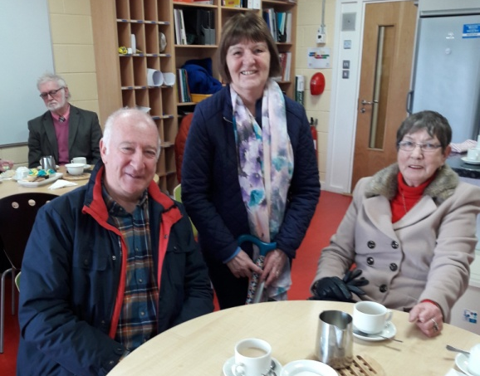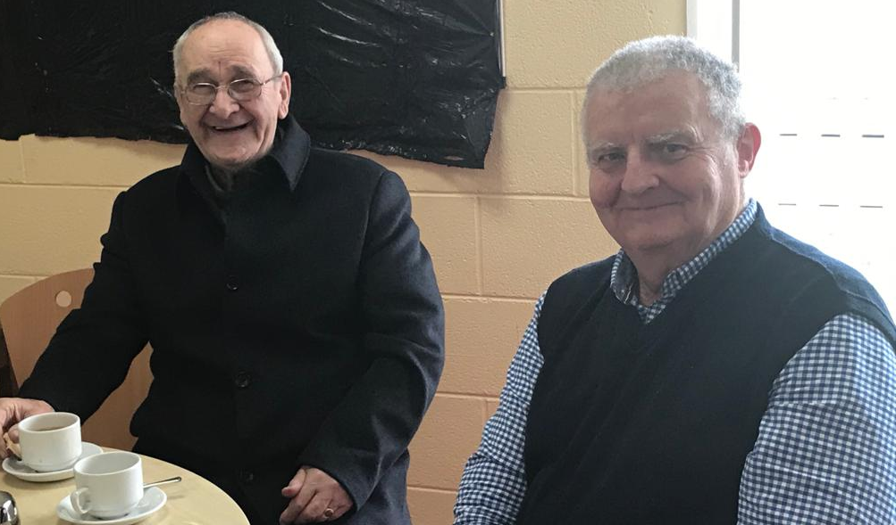

Safer Internet Day (Feb 11th)
To mark Safer Internet Day Miss Ronan arranged a public debate. The Motion was: People should be free to post what they want online. A most interesting debate followed on the rights and responsibilities of free speech.

6th Class are confirmed Feb 15th
