January 2020
Dates for your Diary
January 22nd: Parent Teacher Meetings (St Fiacc’s will close at 2pm for all pupils. *Please collect infants at 1.50pm)
January 29th: Parent Teacher Meetings (St Fiacc’s will close at 2pm for all pupils)*
Jan 26th - Feb 2nd: Catholic Schools Week (Including Grandparents’ Day Jan 29th)
March 4th: First Confessions - 2nd at 7pm.
April 1st: Meeting for parents of next year’s Junior Infants in school hall at 10am.
Feb 15th: Confirmation - 6th at 11am.
May 9th: First Holy Communion - 2nd. at 10.30am and 12.30pm respectively.

Thank you!
To all families returning our family contribution envelope. Date of next contribution: Wed January 8th . Our Christmas jumper morning raised over €300 for school funds at St. Fiacc’s and our calendar sales and donations at our Christmas concert raised €3200 for school funds. The concert was a tremendous success thanks to the efforts of pupils and staff alike but also your attendance as parents. Go raibh mile maith agaibh.

Stay Safe Programme
The Stay Safe Programme will begin this month in all classes. The Stay Safe Programme is a personal safety skills programme for primary schools - both mainstream and special. Its overall objective is to prevent child abuse, bullying and other forms of victimisation. The programme develops children's ability to recognise, resist and report risk situations or abusive encounters.
Please see www.staysafe.ie for further information.

ATTENDANCE
Attendance rate for November – 93.6%
Attendance rate for December – 88.4%
Term One overall – 92.6%
Certificates were awarded to pupils who achieved full attendance last term and to those who reached 95% attendance or greater.

Parent Teacher Meetings
St Fiacc’s Parent Teacher Meetings will take place on January 22nd and January 29th respectively. Appointments will be arranged using the Aladdin Connect App.
On Jan 8th Families with 3 or more siblings will be offered slots. On Jan 9th families with 2 siblings will be offered slots. On Jan 10th everyone else will be offered slots. School will arrange meetings from Jan 13th if parent doesn’t have App.

Supervision
St Fiacc’s will open to receive pupils at 9.00am. No responsibility is accepted for pupils arriving before that time. Classes will commence each day at 9.20am. No pupil should arrive later than 9.15am

Classes end each day at 3.00pm. Parents who wish to have their children escorted home should make their own arrangements to have them met at the school gate and the person to escort them should be at the school not later than 3.00pm as the school cannot accept responsibility for looking after children after that time.

Seasonal Flu
While good attendance is always promoted by St. Fiacc’s, please keep your child at home and away from others as much as possible to avoid spreading infection to others. If they are sick with flu they should stay at home for 5 days from the onset of symptoms.

Catholic School's week
Catholic School's week will run from Sunday Jan 27th - Sunday Feb 3rd. The theme for this year’s week is 'Living in Harmony with God’s Creation'. Grandparents Day will take place on Wednesday 29th January, as part of Catholic School's Week, where one grandparent from each class will talk with the children from 10-10.30am.

FAI Cup comes to St. Fiacc’s and singing at the Fairgreen with Miss Kavanagh and Mr Kelly.

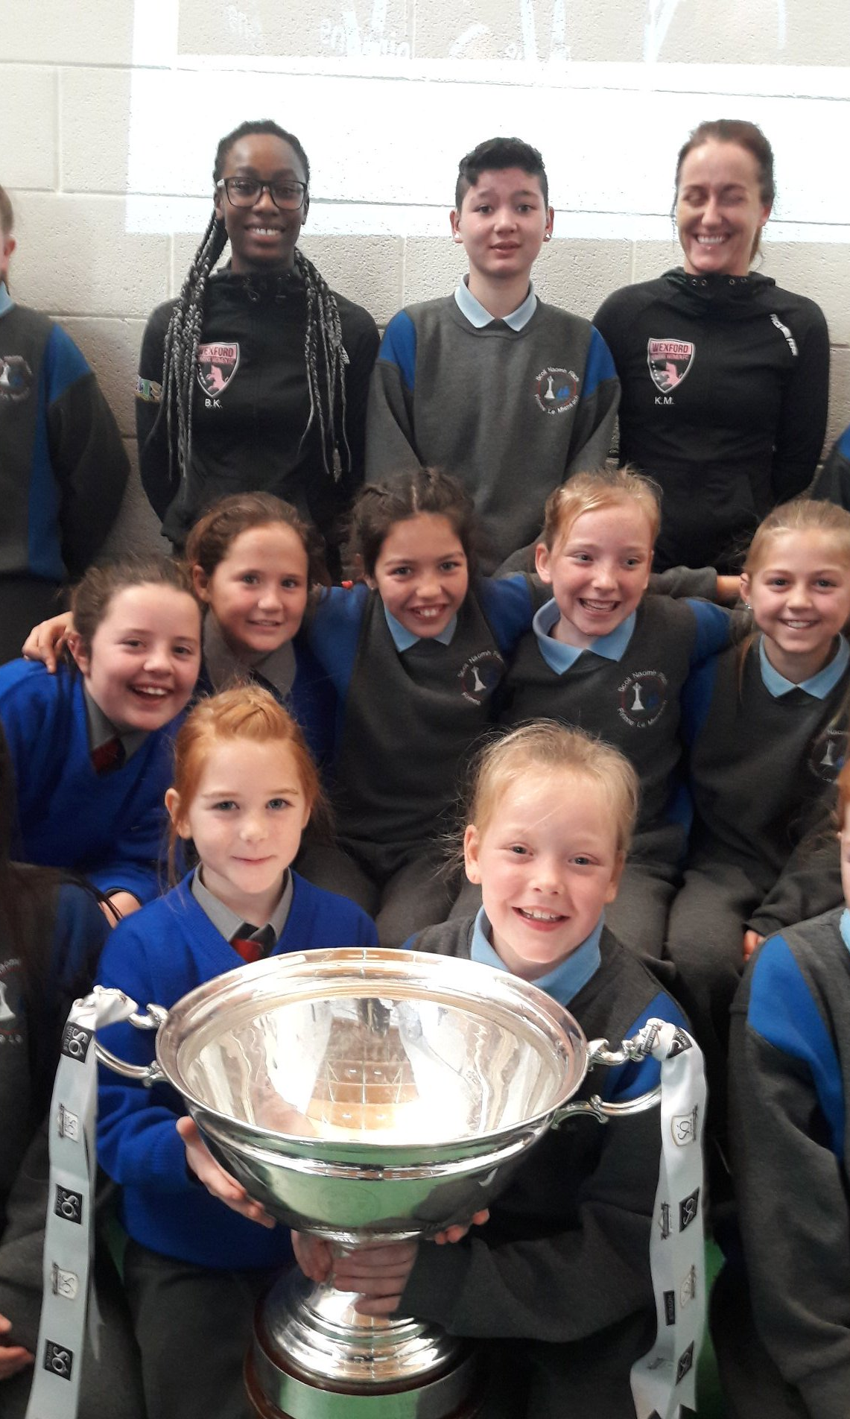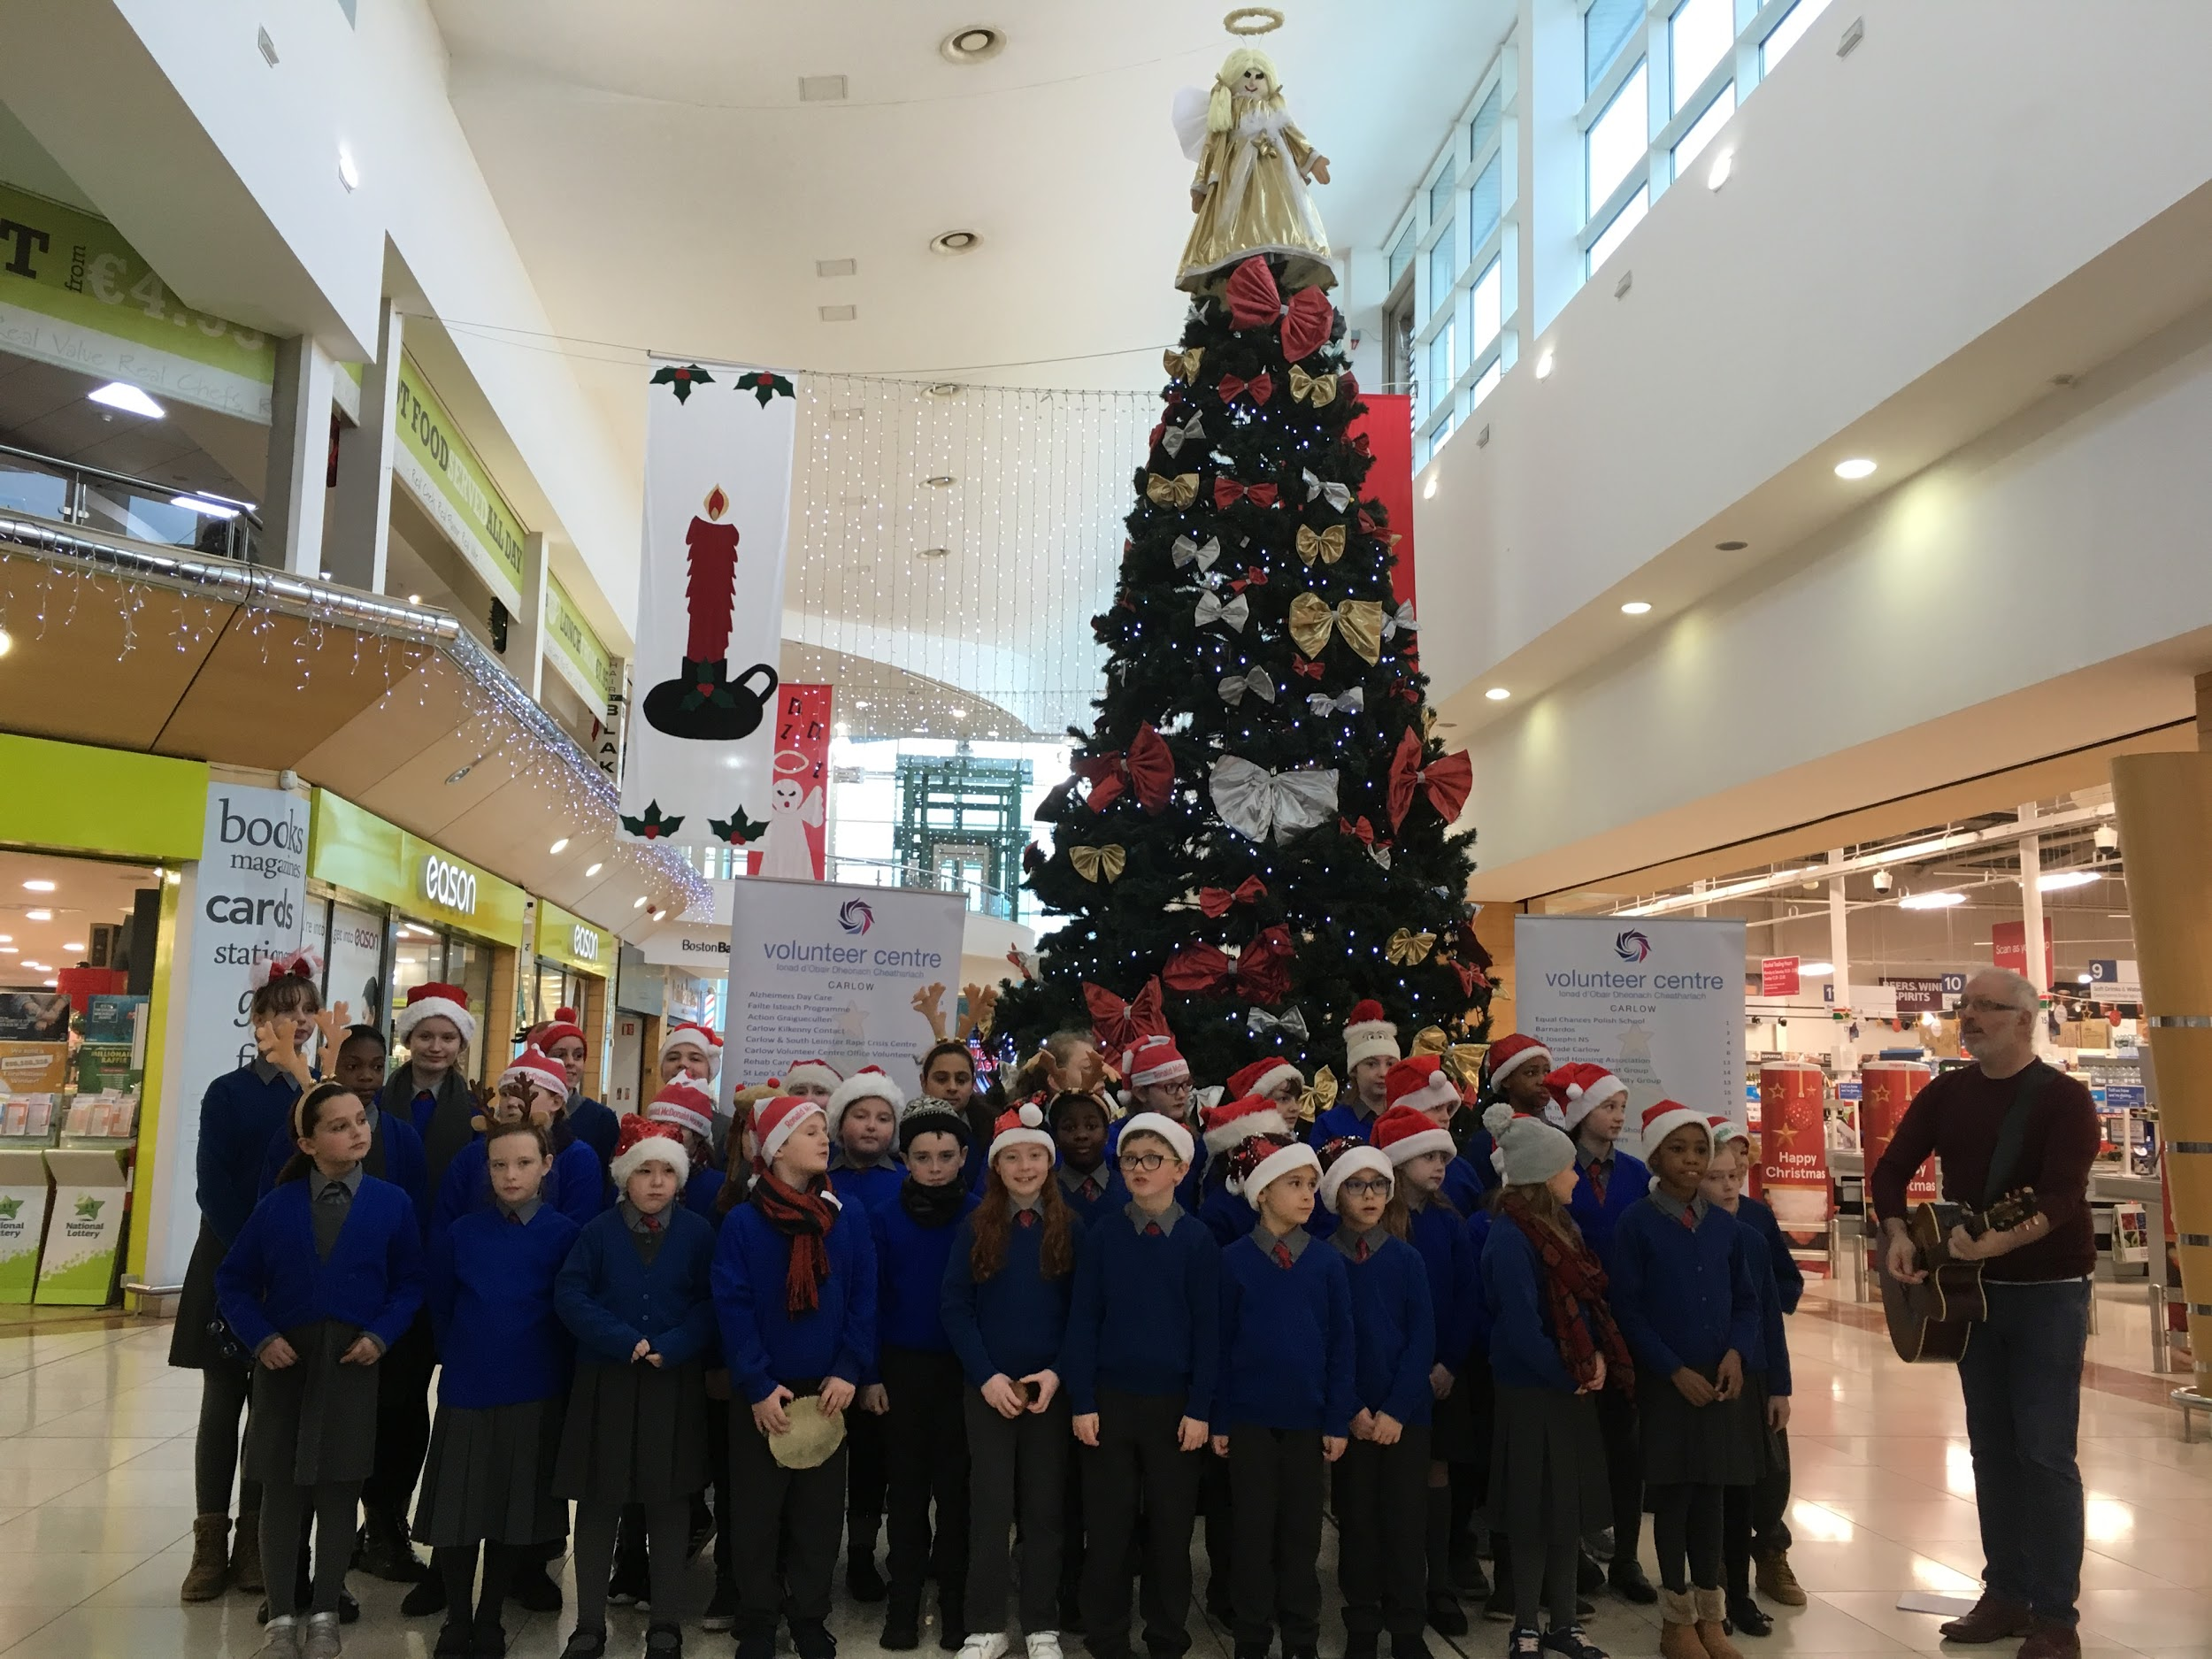

Sixth and Second Classes visit Carlow VISUAL in November.

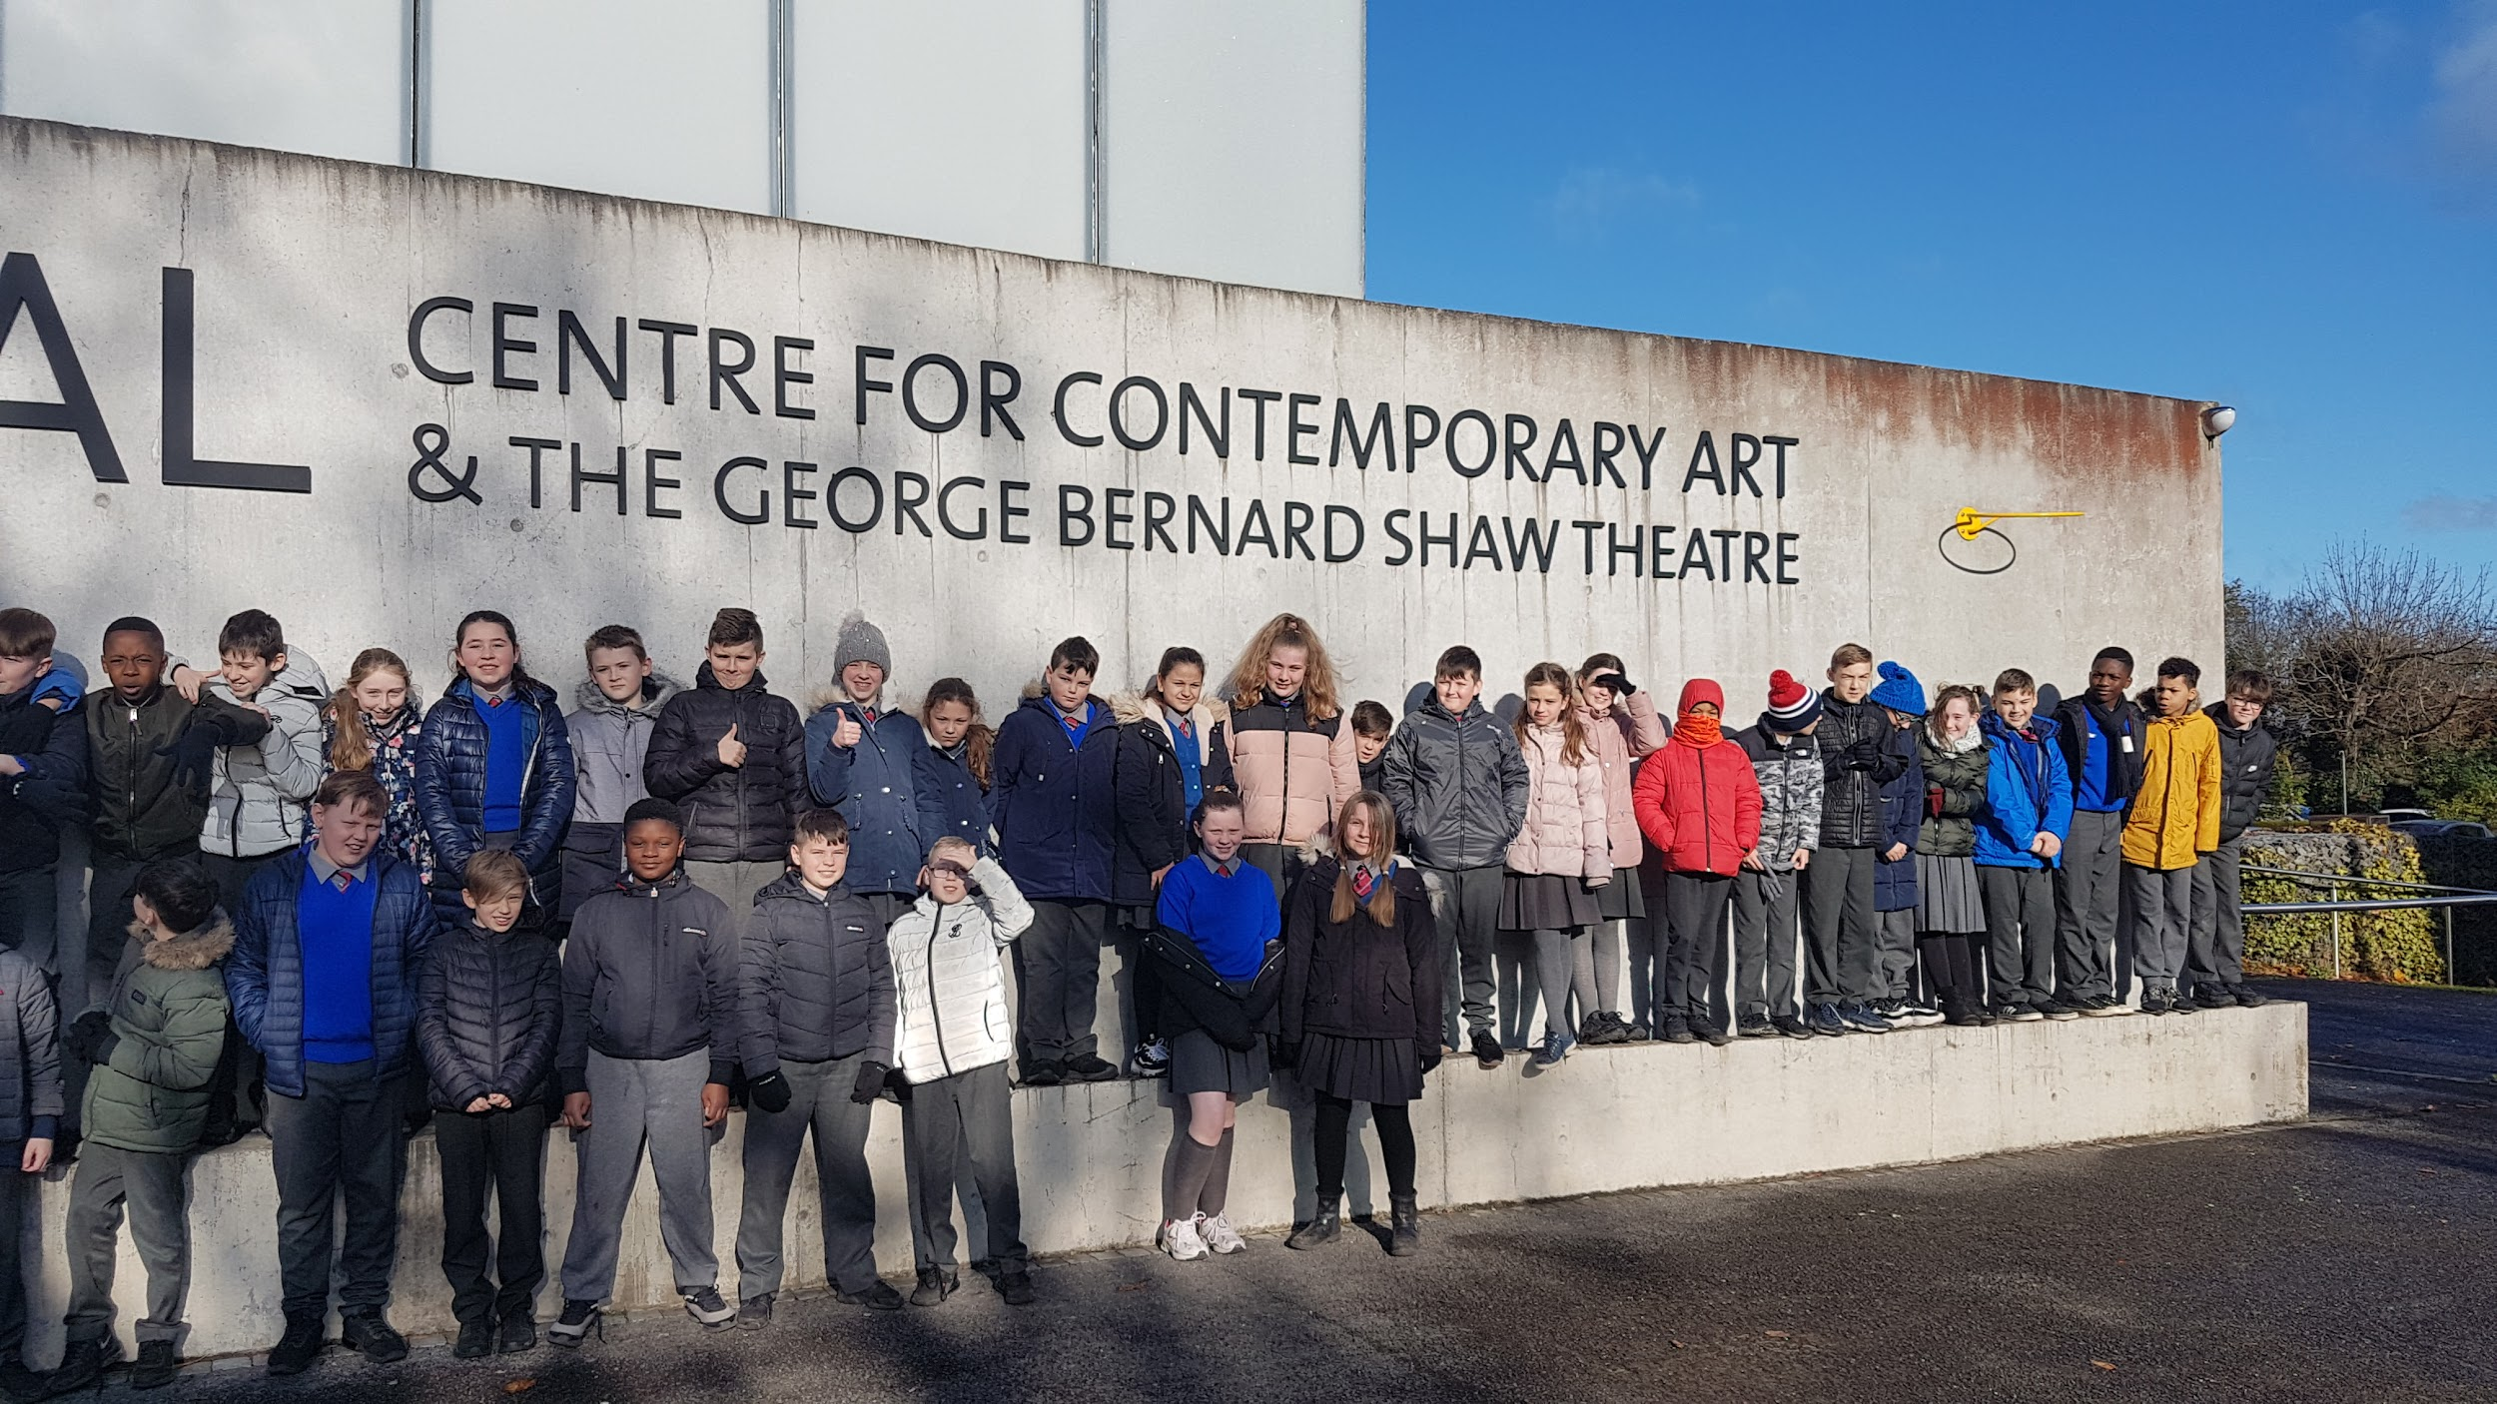
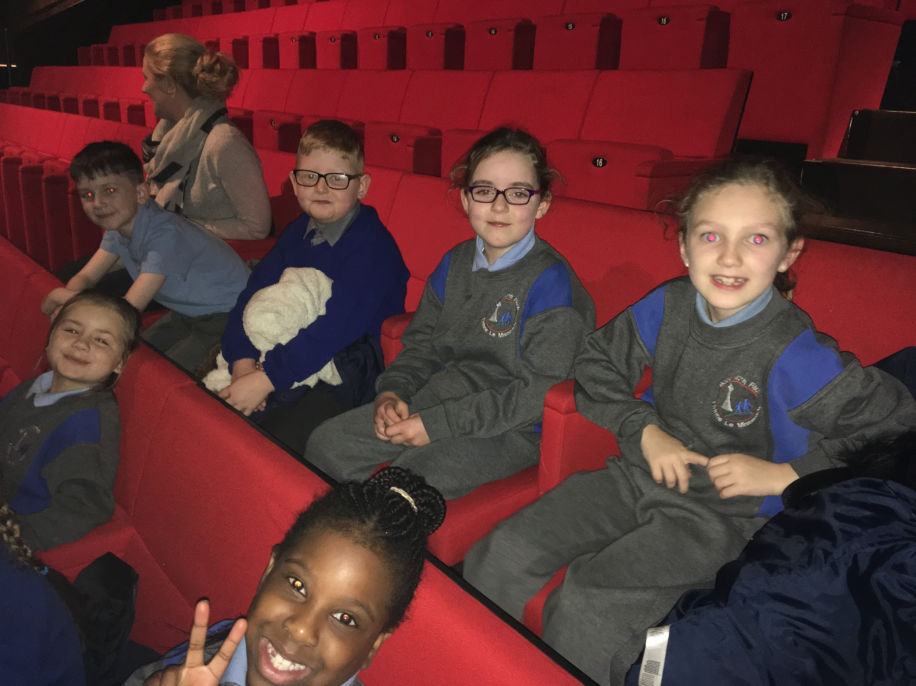

5th visit Carlow County Museum in November while Filip gets his kit in order when Mr Nolan’s class visited the Curragh in December.
