January 2019
Dates for your Diary
January 30th : Parent Teacher Meetings (St Fiacc’s will close at 2pm for all pupils)* *Please collect infants at 1.50pm)
Jan 27th - Feb 3rd: Catholic Schools Week (Including Grandparents’ Day Jan 30th)
Feb 18th - Feb 22nd: School will be closed for Mid-term break.
March 1st: Entrance Assessments for students commencing Post Primary School September 2019 for Carlow Town schools will take place from 2.00pm - 4.30pm approx.
March 19th: St. Fiacc’s will be closed to facilitate Staff Training for the Primary Language Curriculum as sanctioned by the Department of Education.
March 27th: First Confessions - 2nd class.
April 10th: Meeting for parents of next year’s Junior Infants in school hall at 10am.
May 4th: Confirmation - 6th class at 11am.
May 25th: First Holy Communion Masses. (Miss Doheny’s class at 10.30am and Miss Kavanagh & Mr Sheil’s classes at 12.30pm)

SWIMMING
Swimming for Miss Luby’s 4th Class & Miss Mullen’s 3rd class is arranged for the following dates: Feb 5th; 12th; 26th & March 5th; 12th ; 28th. Fees can be paid online.

Thank you!
To all families returning our family contribution envelope. Date of next contribution: Wed February 6th.

Seasonal Flu
While good attendance is always promoted by St. Fiacc’s, please keep your child at home and away from others as much as possible to avoid spreading infection to others. If they are sick with flu they should stay at home for 5 days from the onset of symptoms.

Catholic School's week
Catholic School's week will run from Sunday Jan 27th - Sunday Feb 3rd. The theme for this year’s week is “Catholic Schools. Celebrating the work of our Local Catholic Schools”. Grandparents Day will take place on Wednesday 30th January, as part of Catholic School's Week, where one grandparent from each class will talk with the children from 10-10.30am.

Prayer Service with Bishop Denis
It is that time of year again when Bishop Denis is preparing to set off on his journey of Confirmation around the diocese. Since his arrival in the diocese we have marked this with a short prayer service during which Bishop Denis fills his Oil Stock with the Sacred Oil of Chrism with which he will anoint Confirmation candidates in the coming year. Mr Bolton will arrange for our Confirmation classes to gather in the Cathedral of the Assumption, Carlow at 12:00 noon on Friday, February 1st.

Peace Proms 2019
On Saturday 9th February, our School choir will take park in the Peace Proms concert in Waterford IT. They have been doing a lot of preparation for this event which will feature many schools from all over the country. We wish them all the best and hope they enjoy the experience.
Some tickets may still be available if parents of choir members wish to contact the Peace Proms organisers.

St. Fiacc’s Debating Team
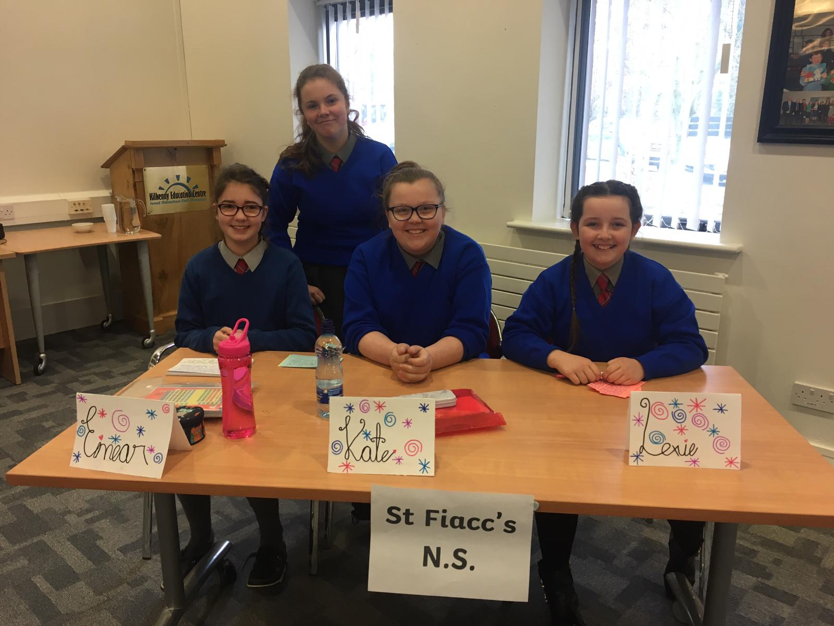

Mile on Wednesdays
From February 6th, pupils on the Senior yard will be invited to jog a mile distance around our senior yard perimeter beginning at 9.05am.

Our Junior Students of the Week (Jan 25th)

Graiguecullen 5K & 10K challenge
Graiguecullen GAA club are hosting a 5 & 10K run/walk/jog on Sunday February 17th at 11am as a fundraiser for both club and Carlow/Kilkenny Homecare team. Your support as always would be appreciated.

