December 2019

Dates for your Diary
Dec 3rd – January 28th: Swimming for MissRonan (5th) & Miss Mullen (3rd ) – 6 weeks.
Cost €4 per pupil. (Total €24 - online payment option)
Dec 6th: School Choir performing in Fairgreen at 10.30 approx. (see below)
Dec 9th: Mass at 11.30.to mark the feast of the Immaculate Conception. Pupils to bring a food item (see table)
Dec 19th: St Fiacc’s Christmas concert. 3rd - 6th. This concert will take place in St. Fiacc’s Hall. The concert will be in two parts. Infants - 2nd concert will run from 11am - 12.30pm.
3rd - 6th concert will run from 1pm - 2.30pm. Donations will be accepted at the door and calendars will be for sale at €10.
Dec 20th: St Fiacc’s closes at 12.00pm for the Christmas Holidays and reopens on January 6th.
Jan 6th: Pupils return to school. Mass at 1:30 to celebrate the feast of the Epiphany.

Christmas Carols at the Volunteer Tree.
A Christmas Tree, dedicated to Carlow’s volunteers, will be unveiled in the Fairgreen Shopping Centre on Friday 6th December 2019. The Volunteers’ Christmas Tree will be on display throughout the Christmas season and aims to bring awareness of the large number of people who volunteer in our county.

St Fiacc’s school choir will lead volunteers, family and shoppers in festive cheer with a Christmas Sing a Long in the Fairgreen. The whole event will start about 10.30 am with the choir singing for about 30 minutes.

Christmas Shoebox Appeal
Thanks to everybody who contributed to our shoebox appeal. As a result 140 boxes of gifts will be heading to children in need.

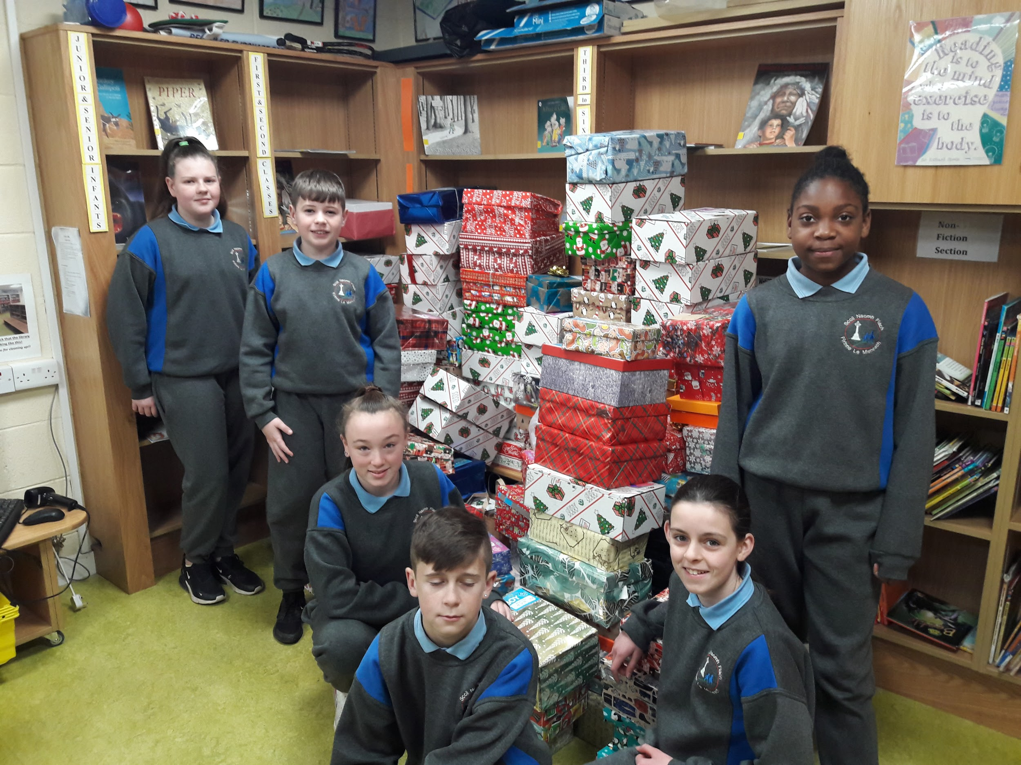

Green School
As a Green School we discourage pupils purchasing Christmas Cards for each other. Instead pupils will design cards as an Art Activity.

School Calendar
St Fiacc’s 2020 school calendar will be for sale at our Christmas concert. It costs €10. Many thanks to all the businesses who took out an ad in the calendar. Order form attached to newsletter.

List of food items for Christmas Hampers : Mass of the Immaculate Conception : December 9that 11.30
Junior Infants:  Ms. Doyle: Packets of Soup  Ms. Nolan: Ketchup  Ms. O’Brien: Large bag of Sweets | Senior Infants :  Ms. Hutton : Tea Bags  Ms. Mc Carthy : Gravy granules  Ms Reddy: Tin of Beans
First Class :  Ms Kinsella : Tin of Spaghetti  Ms.Hogan :Tins of tuna/sardines  Ms Davitt: Curry Sauce | Second Class :  Ms. Frayne : Custard  Ms. Kavanagh : Tin of Creamed Rice
Third Class :  Ms. Coakley : Box of Pringles or Similar  Ms Mullen : Tub of Hot Chocolate Powder  Ms.Walsh:: Nutella | Fourth Class :  Ms. Hennessy :Jam  Ms.Luby : Mayonnaise  Ms.Ivory: Jam
Fifth Class :  Ms. Ronan :Tins of Fruit  Miss Scully :Jar of Cranberry Sauce  Mr Sheil: Tins of Fruit | Sixth Class:  Ms Delaney: Packet of Biscuits  Mr. Nolan: Mineral  Ms.Minnock:: Mineral

Thank you!
To all families returning our family contribution envelope. Date of next contribution: Wed Dec 4th.

Attendance rate for October – 94.5%. Well done all! | Well done to Shirley Lidierth and Dermot Kinsella who have been elected as Parent Nominees to our new Board of Management | We had a very imaginative Hallowe’en fancy dress and raised €480 in the process. Thanks to all involved

Girls’ Football Final
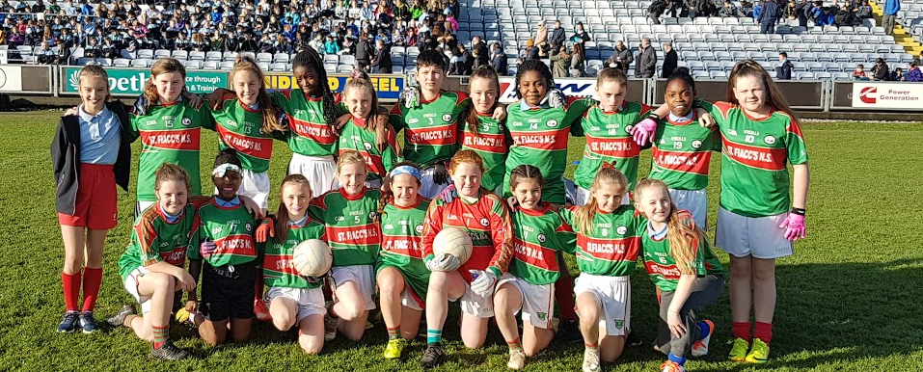
Our girls lost narrowly in the Roinn 1 final to Portlaoise and were a credit to our school and club with their conduct both on and off the field. Thanks to Miss Minnock and Miss Ronan for coaching the girls.

Tidy Schools award
Well done to all members of our school community and our Green Schools Committee for working hard to keep our school clean. We were awarded 3rd place in Carlow’s Tidy Schools last month.
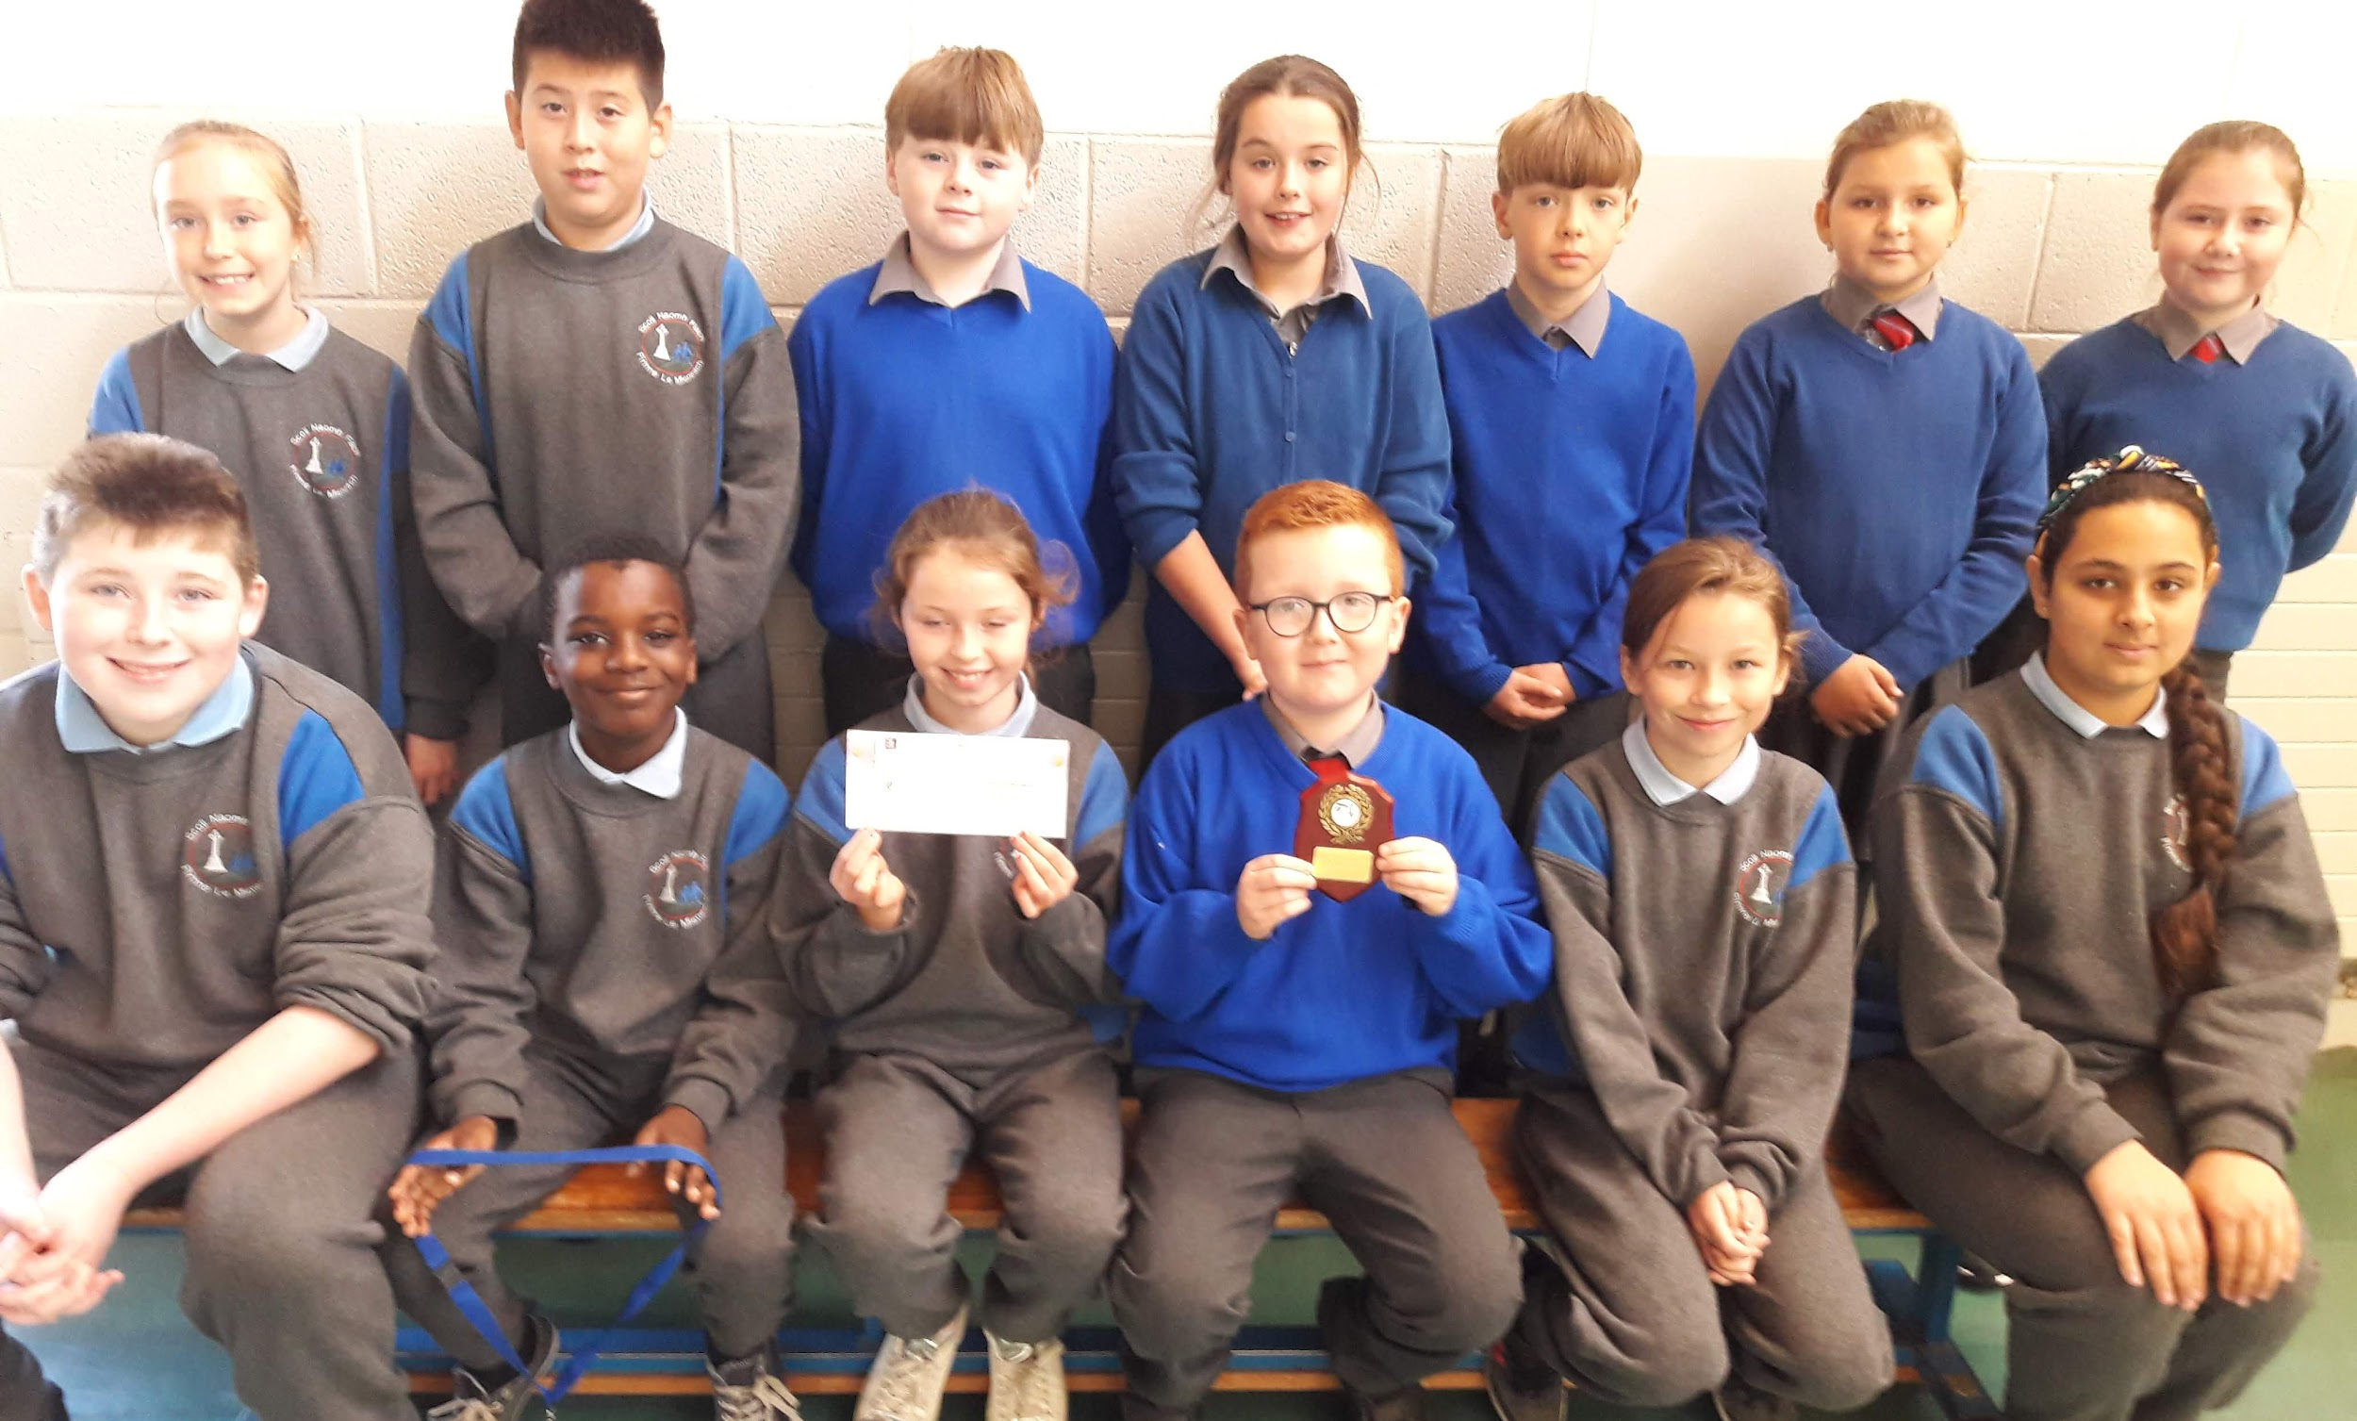

FAI CUP GLORY
Our Past pupils Kylie Murphy and Blessing Kingsley brought the FAI cup to St. Fiacc’s on November 15th triggering great joy among our boys and girls!

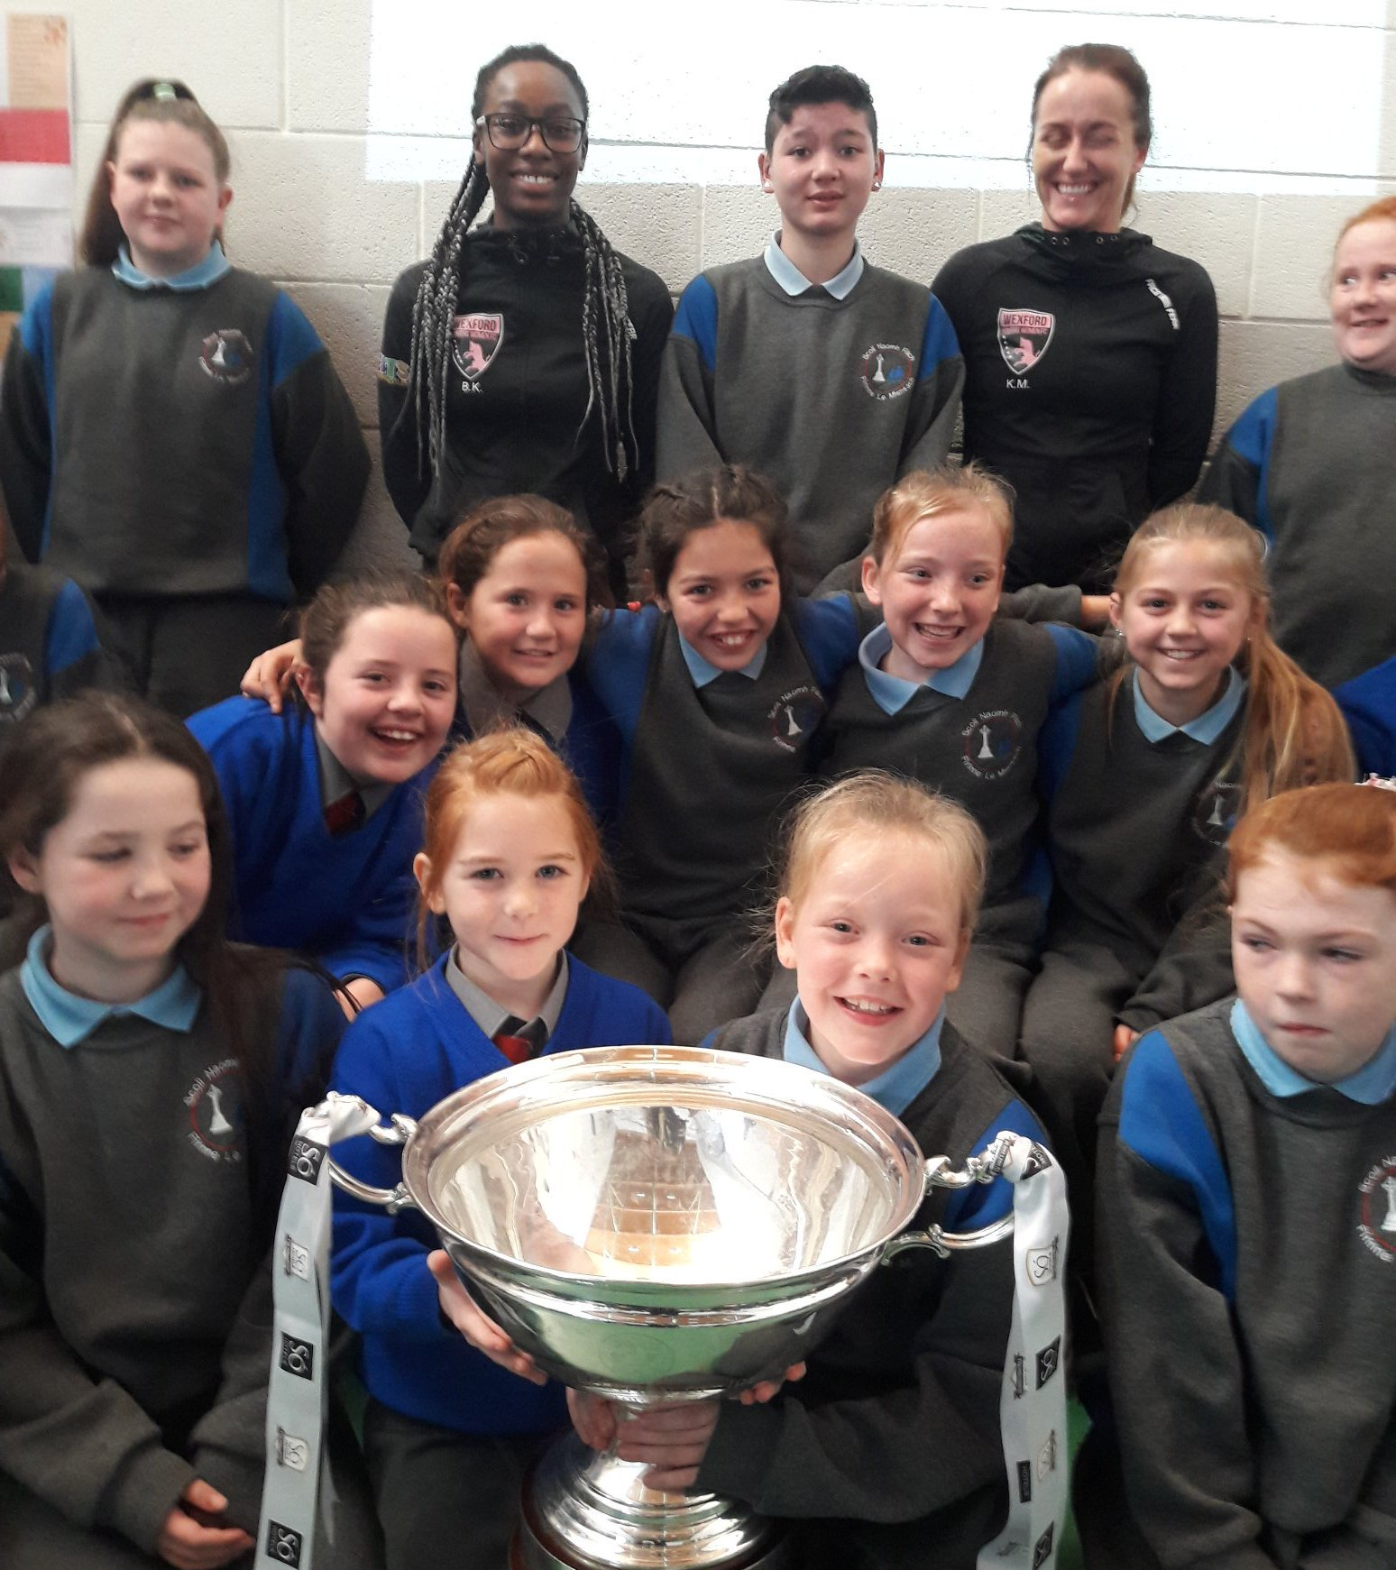

Hallowe’en Energy Theme
Some amazing costumes were on display Oct 25th at our school focusing on energy awareness. Here’s a sample:
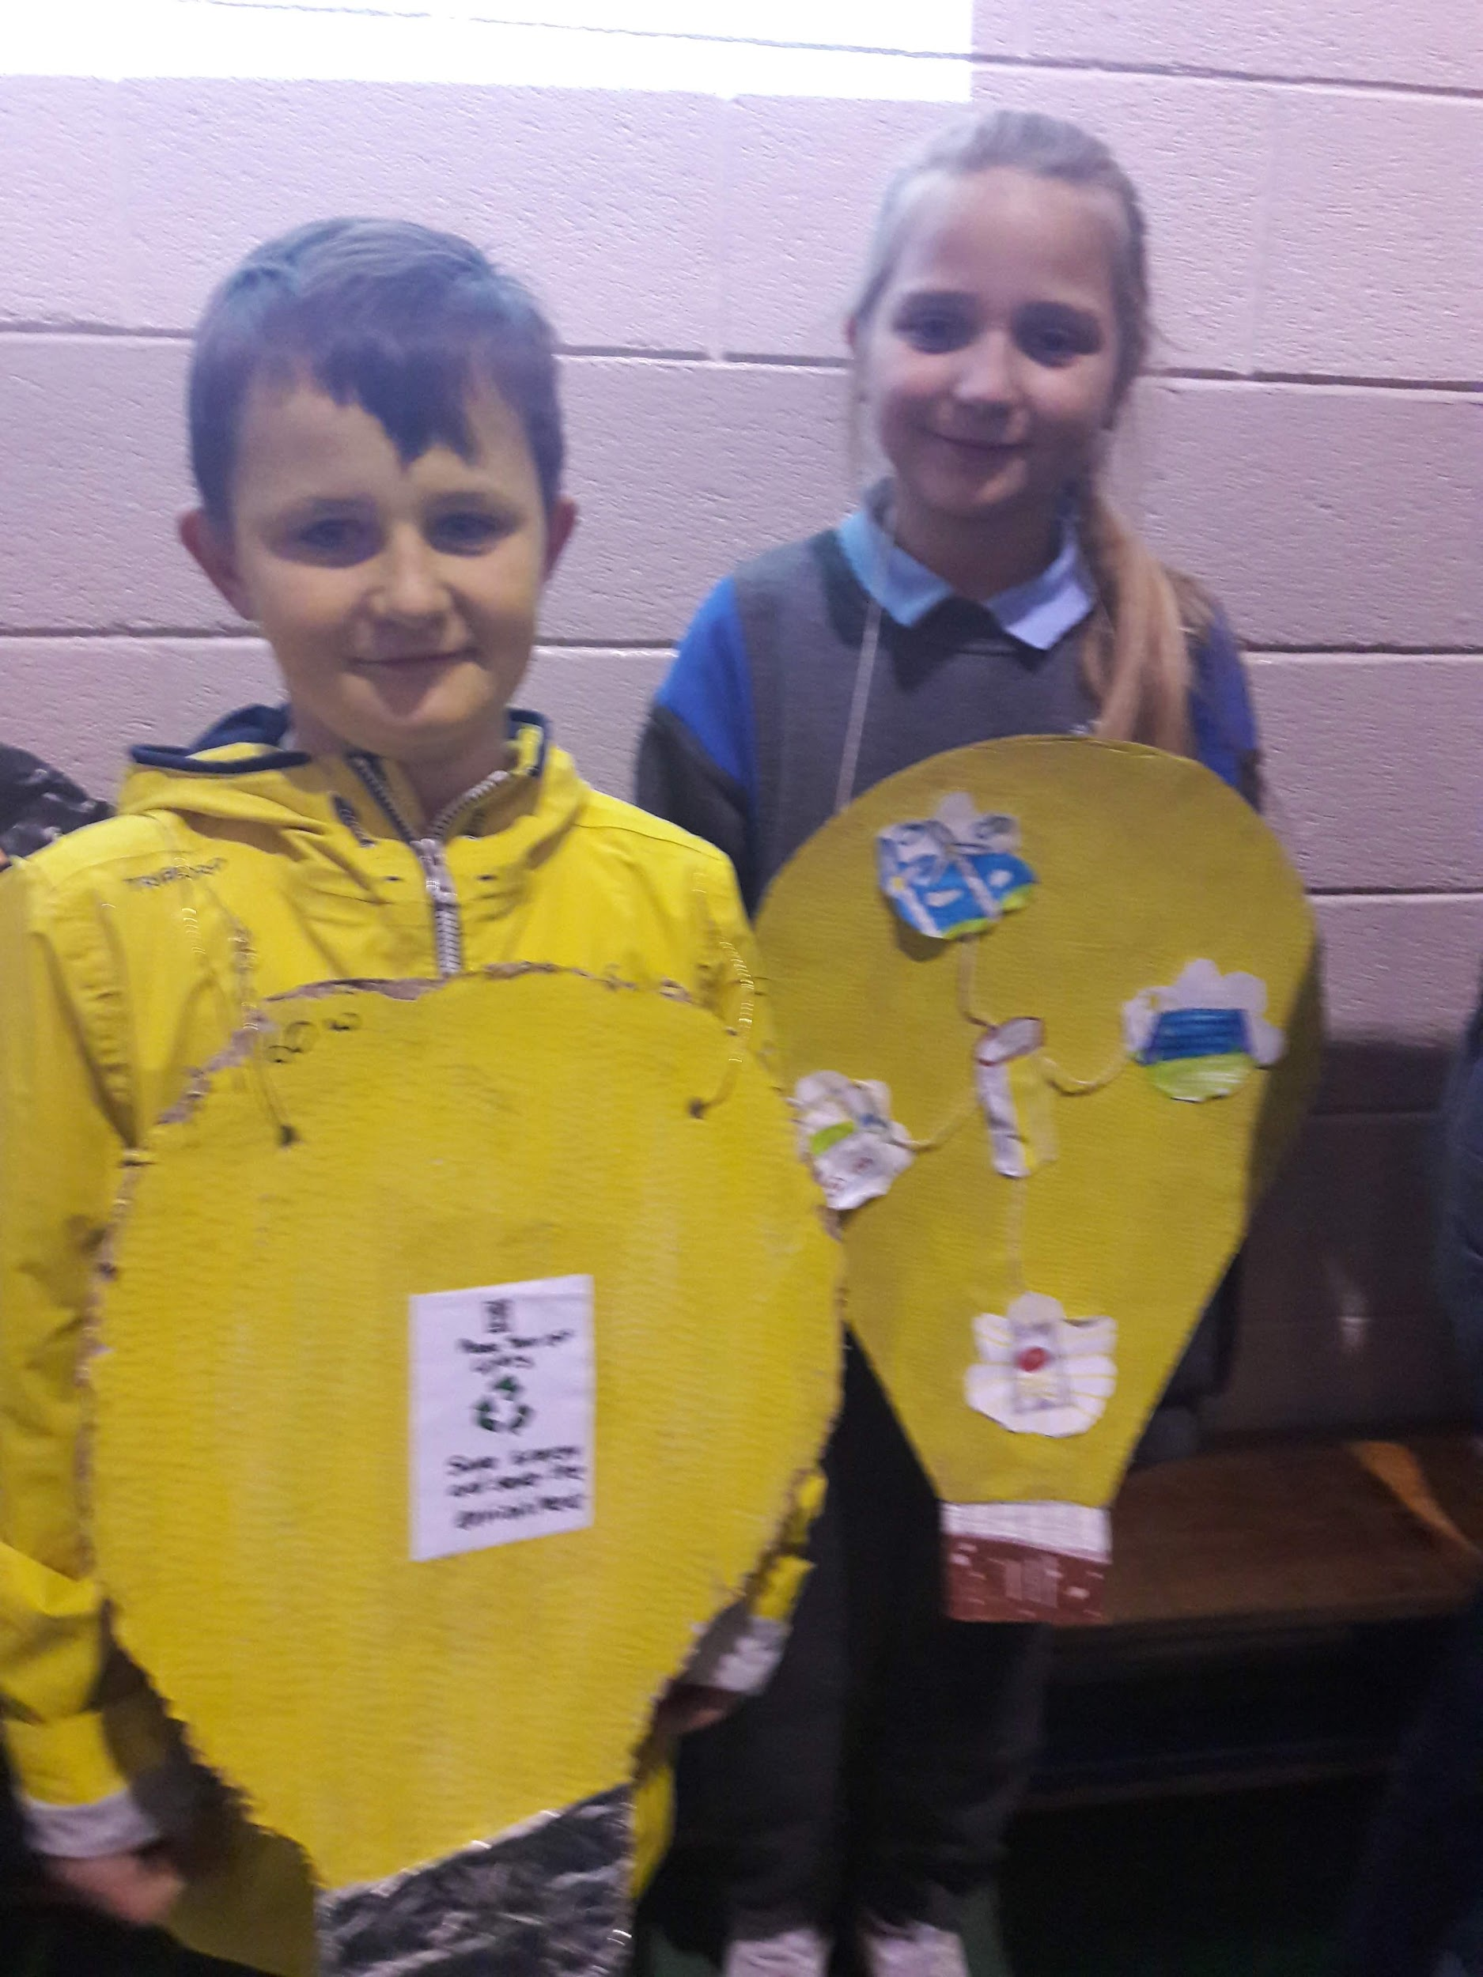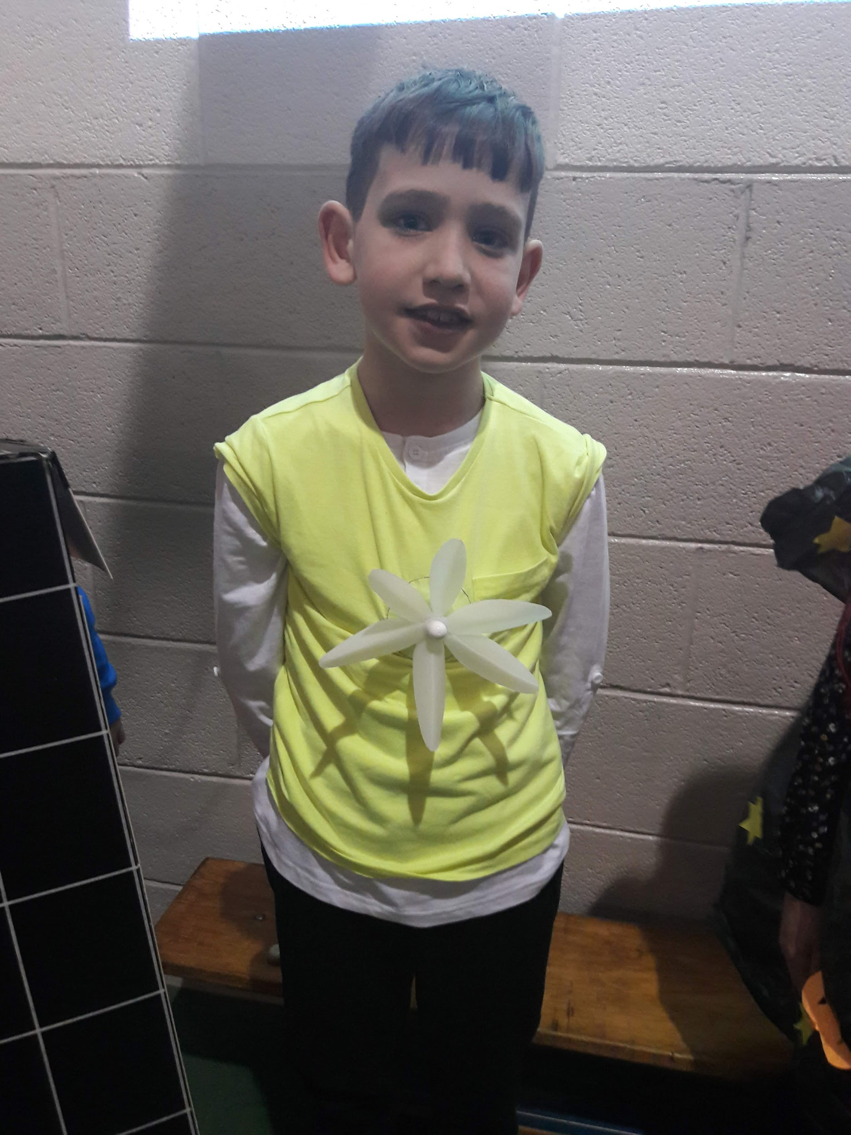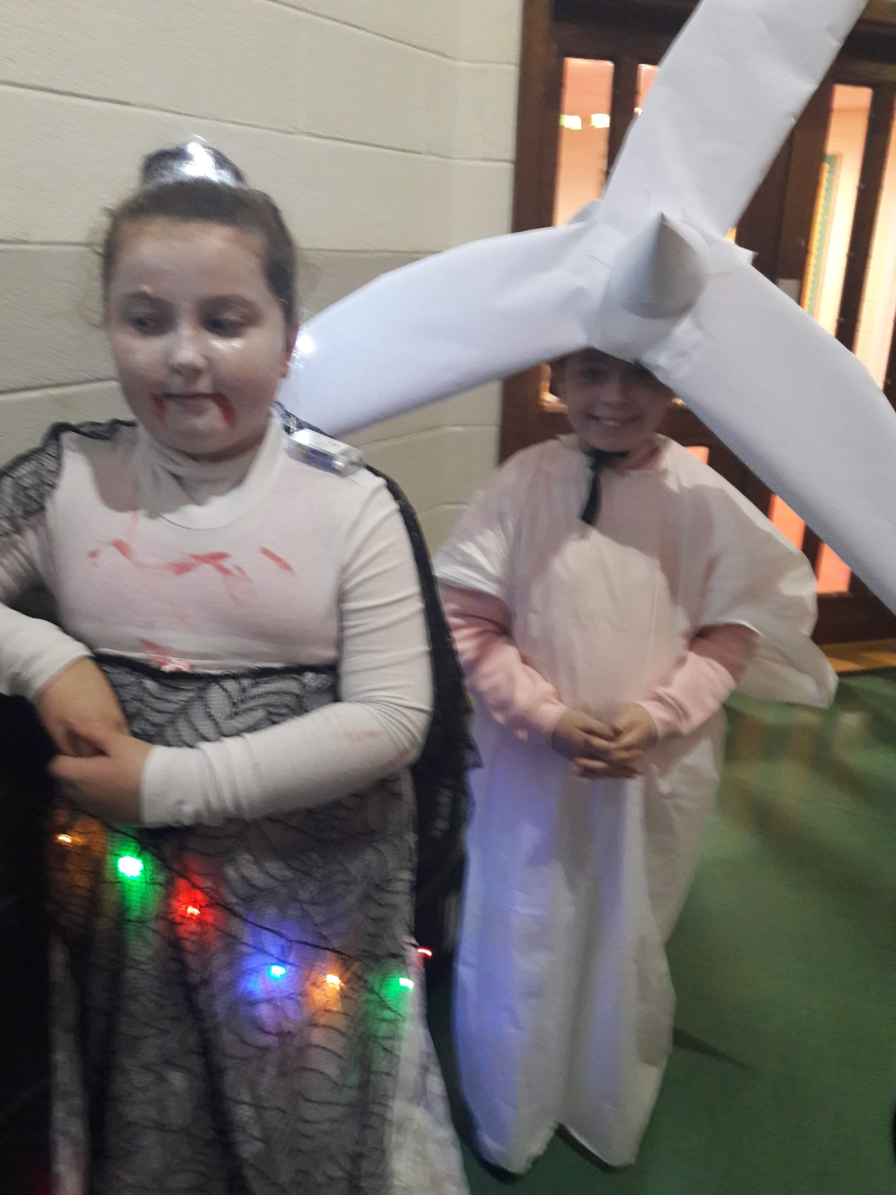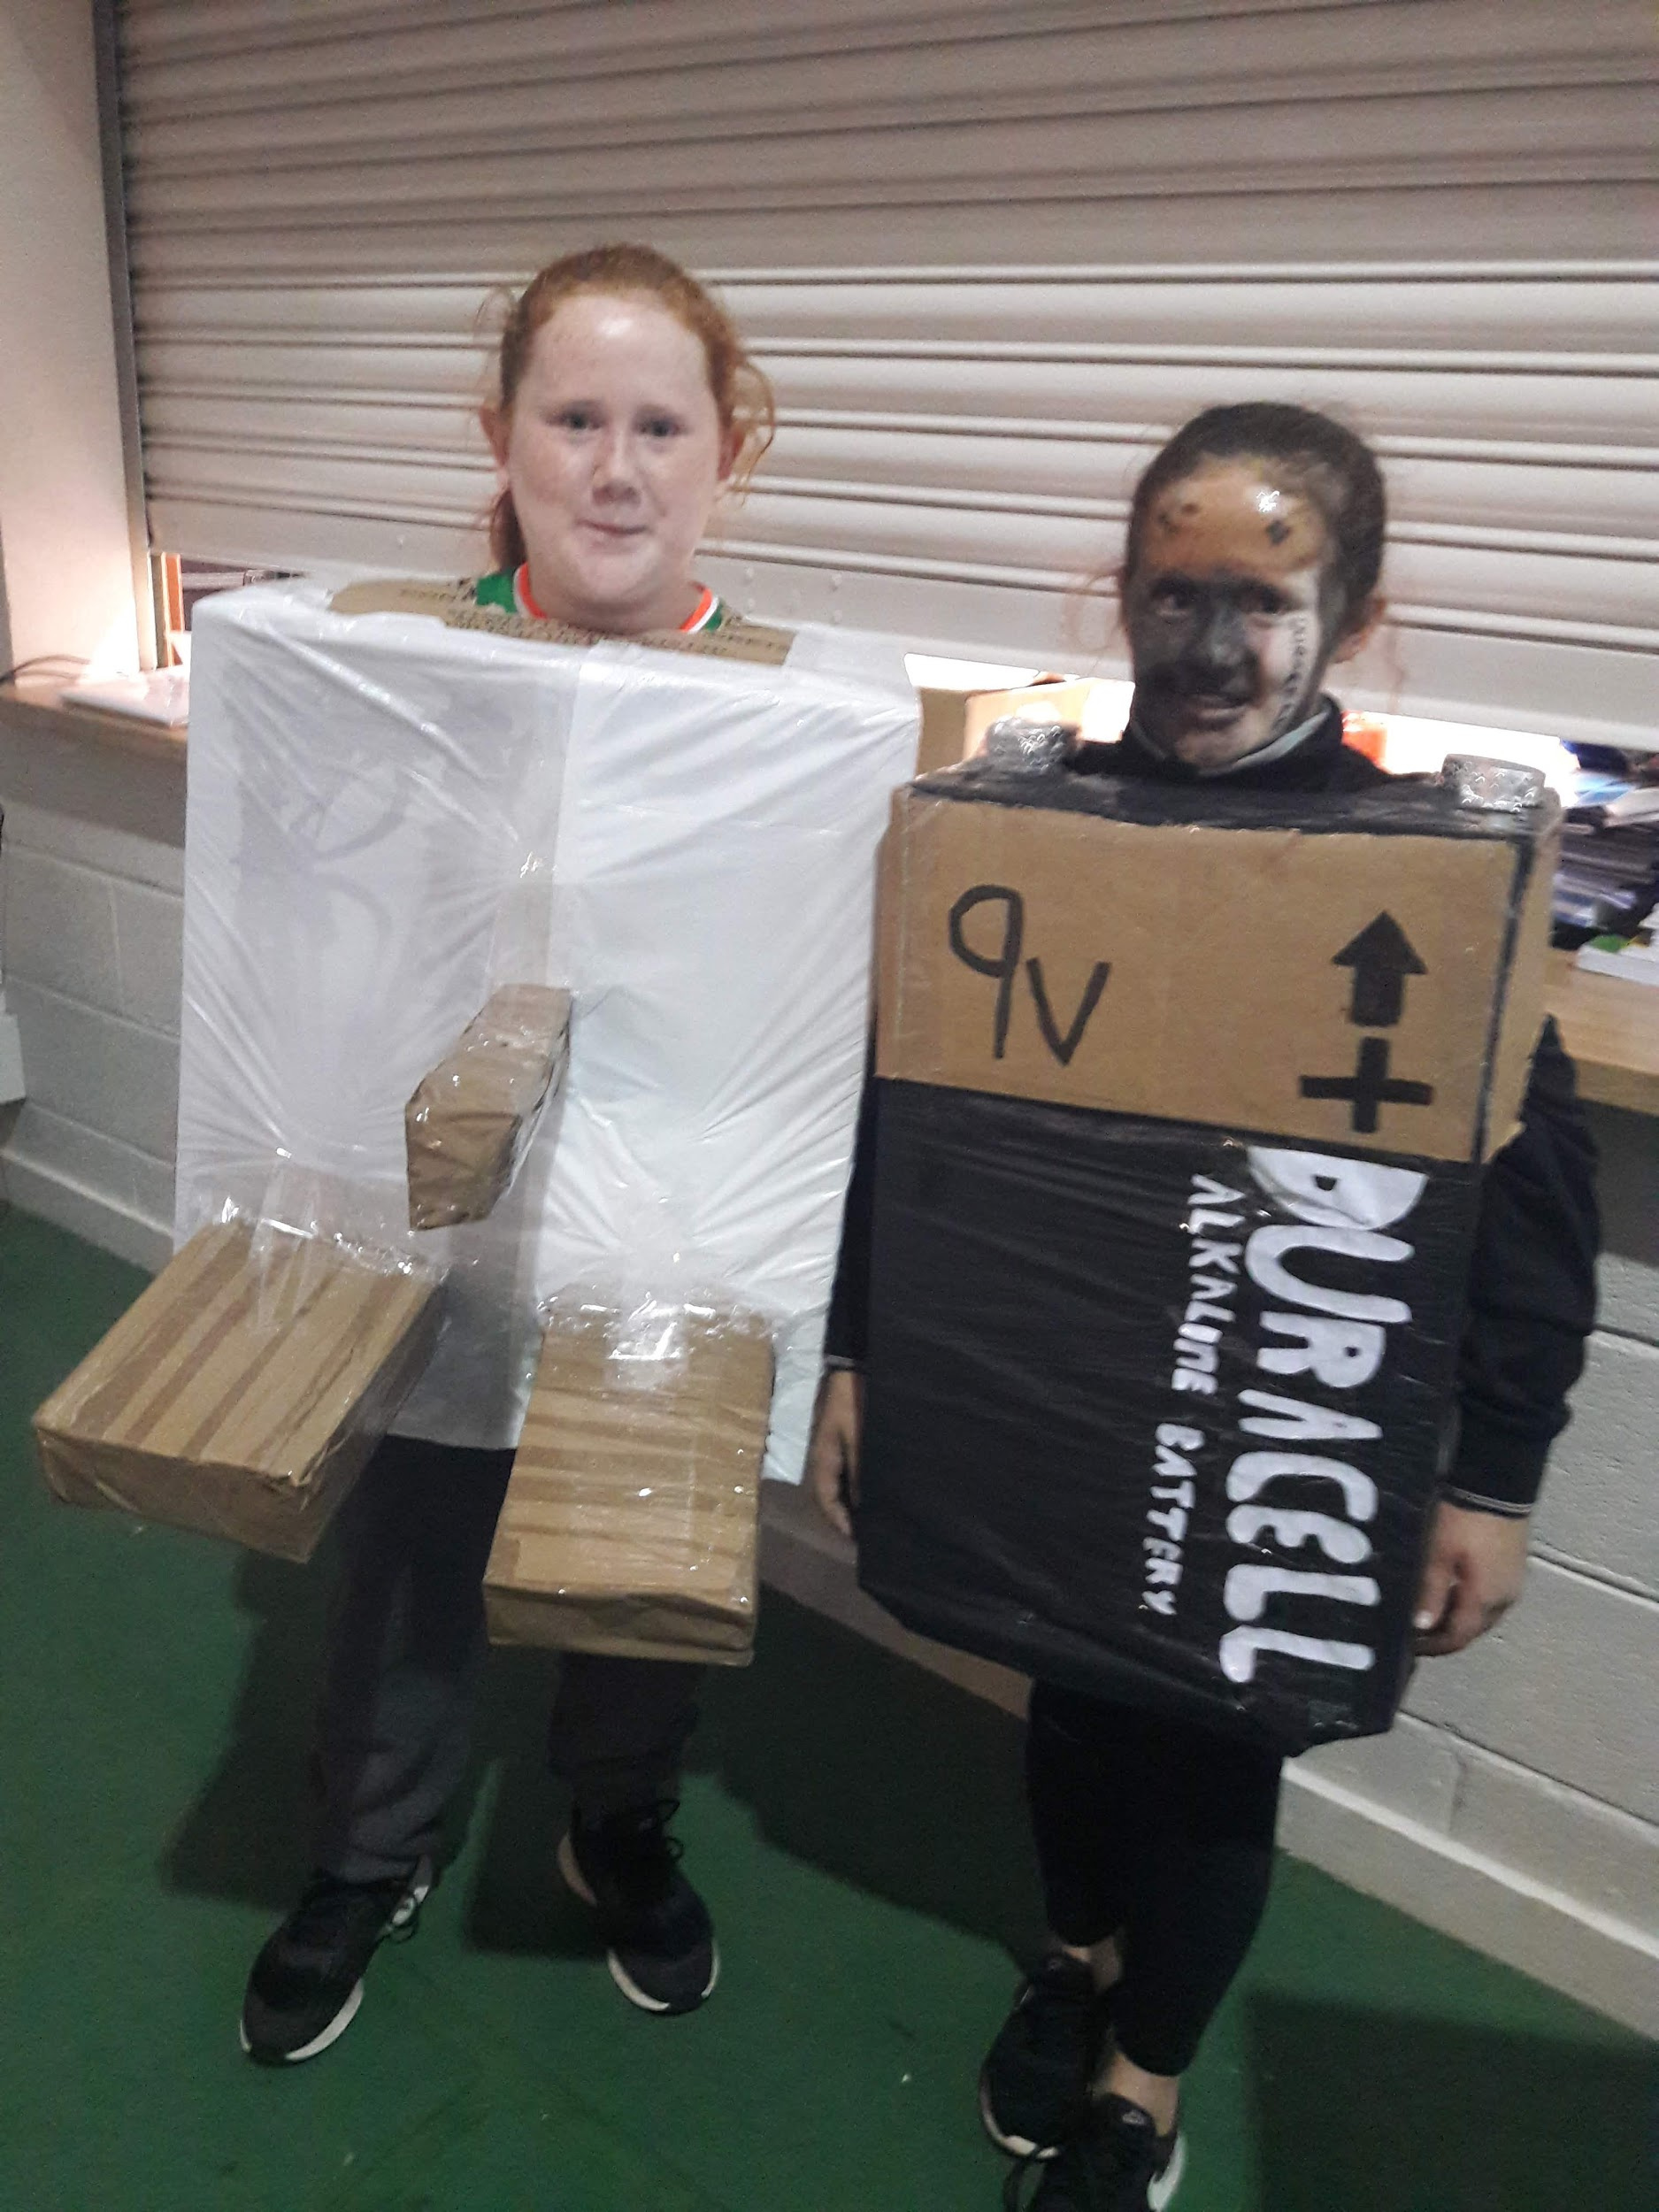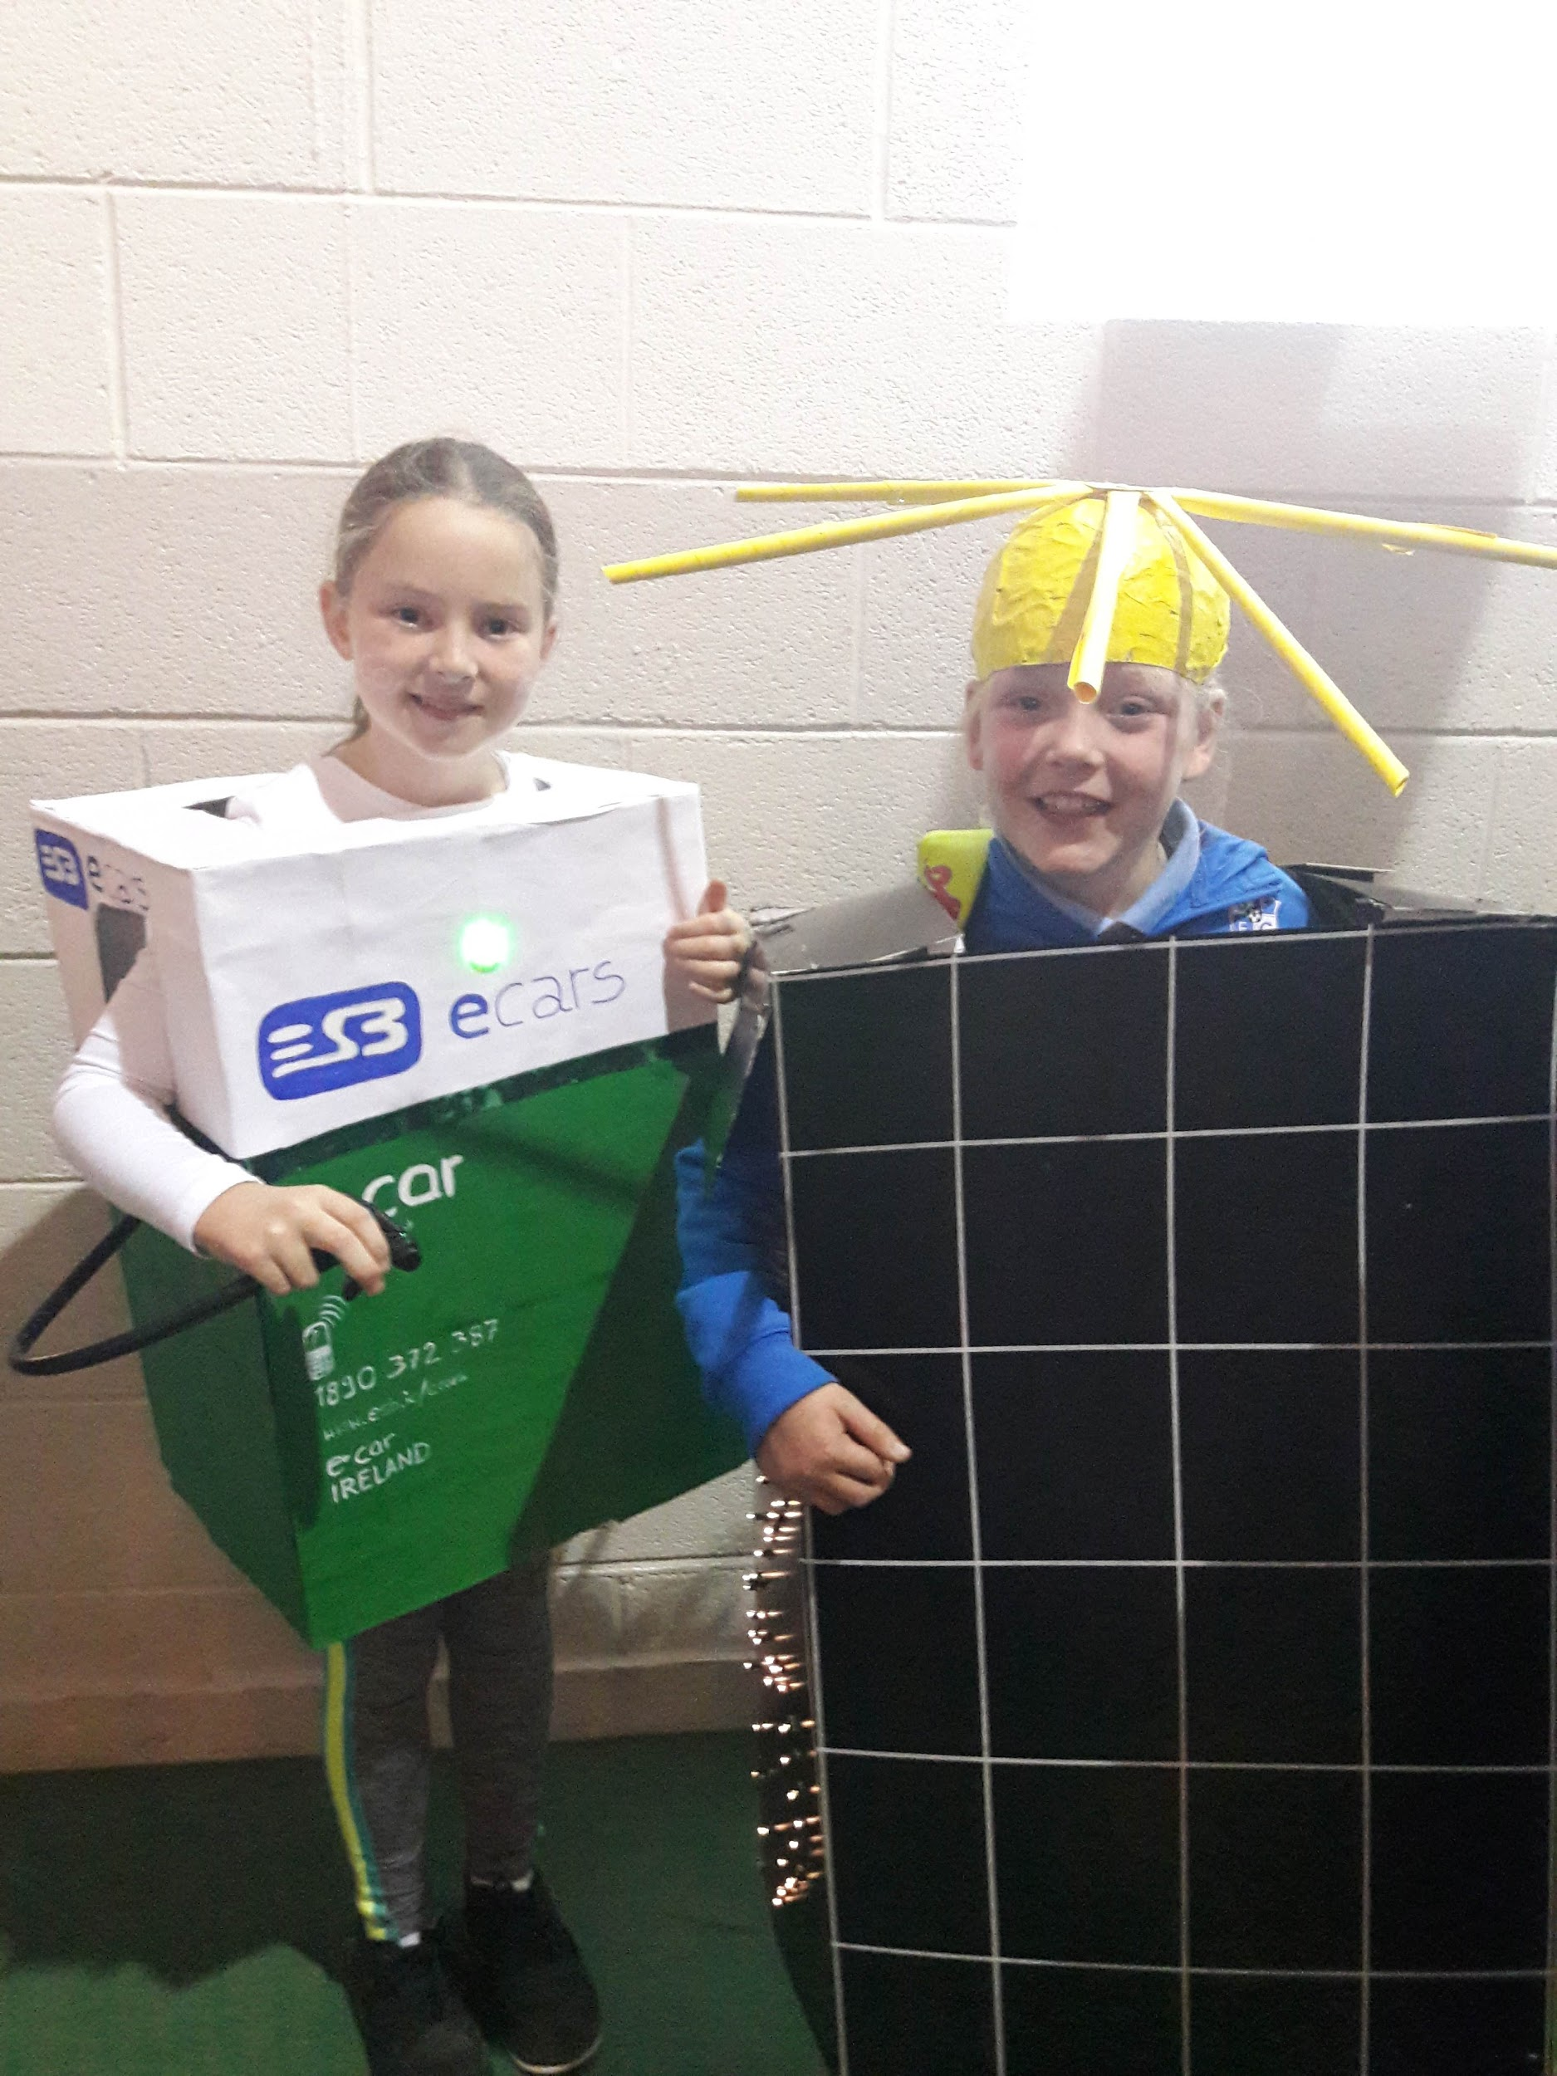

Winners of our EVERY SCHOOL DAY COUNTS Art Competition

Senior Infants | Akifa Ferdous  Mandy Yan  Gabriela Lukasiewicz  Abbie Shannon  Alice Doyle Fitzpatrick  Sofia O’ Sullivan
First Class | Tia Keating  Cian O’ Shea  Lucas Ghiorghita  Maia Deac  Ruairi Kavanagh  Kasper Bryzik
Second Class | Hannah Sabanda  Dylan Doyle  Maisy Aylward  Kelsi May Timmons
Third Class | Ben Frydlewicz  Mikey Murnane  Karla Lazar  Cailyn Thompson  Lea Chividzhiyan  Emanuel Lukacs
Fourth Class | Klara Sykta  Kian Scully  Rebecca Miranda  Filip Dul  Daragh McEvoy  Samuel Germaine
Fifth Class | Abbey O’ Shea  Matt Czoraj  Stash Flejszar  Shauna Fitzpatrick  Ryan Scott Doyle  Nicole Hurley
Sixth Class | Karina Maclulyte  Chloe Tierney  Violet Kelly  Jan Flejszar  Milly Byrne Hurley  Nicola Marcinow

