December 2018
Dates for your Diary
Dec 4th – January 29th: Swimming for Miss Whelan (5th) & Miss Killeen (4th ) – 6 weeks.
Cost €4 per pupil. (Total €24 - online payment option)
Dec 7th: School Choir performing in Fairgreen at 10.30 approx. (see below)
Dec 7th: Mass at 12.00. Pupils to bring a food item (see table)
Dec 13th: St Fiacc’s Christmas Pageant Juniors-2nd. This concert will take place at St. Clare’s Church at 11.00am.
Dec 14th: St Fiacc’s Christmas concert 3rd - 6th. This concert will take place in St. Clare’s Church at 11.00am.
Dec 21st: St Fiacc’s closes at 12.00pm for the Christmas Holidays and reopens on January 7th.
Jan 7th: Pupils return to school.

Christmas Carols at the Volunteer Tree.
A Christmas Tree, dedicated to Carlow’s volunteers, will be unveiled in the Fairgreen Shopping Centre on Friday 7th December 2018. The Volunteers’ Christmas Tree will be on display throughout the Christmas season and aims to bring awareness of the large number of people who volunteer in our county.

St Fiacc’s school choir will lead volunteers, family and shoppers in festive cheer with a Christmas Sing a Long in the Fairgreen again on the 7th December. The whole event will start about 10.30 am with the choir singing for about 30 minutes.

Christmas Shoebox Appeal
Thanks to everybody who contributed to our shoebox appeal. As a result 134 boxes of gifts will be heading to children in need.

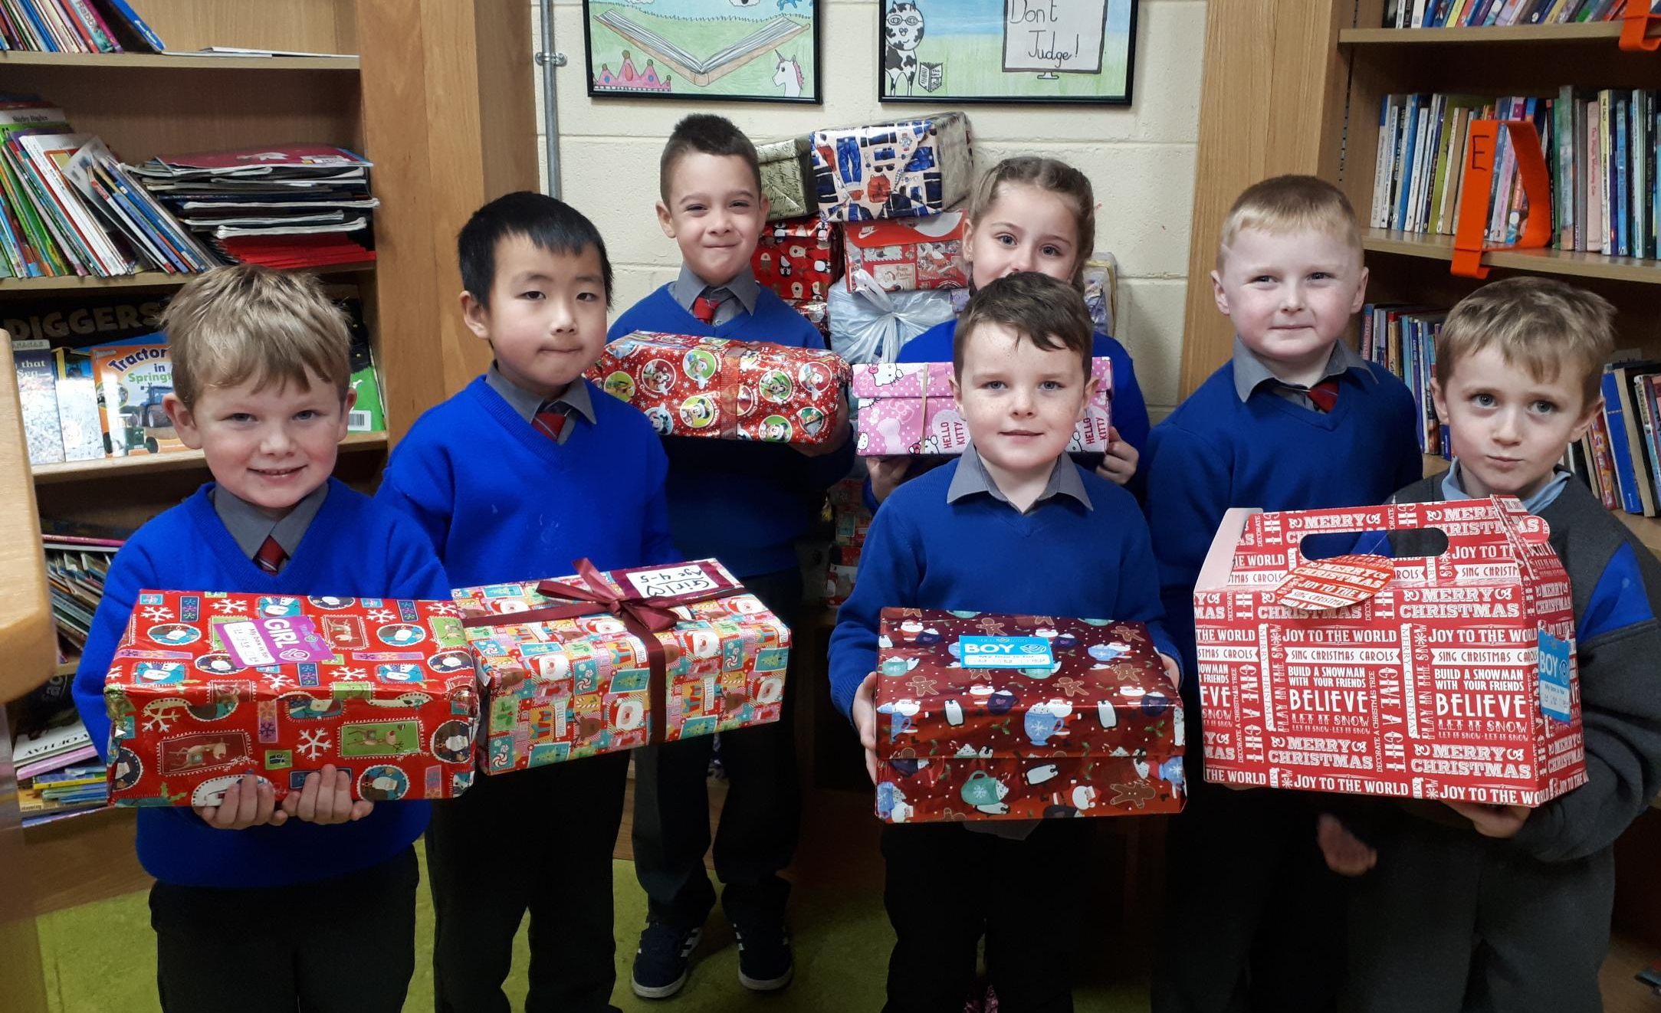

School Calendar
St Fiacc’s 2019 school calendar will be for sale at our Christmas concerts. They cost €10. Many thanks to all the businesses who took out an ad in the calendar. Order form attached to newsletter.

List of food items for Christmas Hampers : Mass of the Immaculate Conception : December 7that 12.00
Junior Infants:  Ms. Hennessey: Packets of Soup  Ms. Nolan: Ketchup  Ms. O’Brien: Ketchup | Senior Infants :  Ms. Hutton : Tea Bags  Ms. Mc Carthy : Gravy granules  Ms Reddy: Tin of Beans
First Class :  Mr McLoughlin : Tin of Spaghetti  Ms.Hogan :Tins of tuna/sardines | Second Class :  Ms. Doheny : Custard  Ms. Kavanagh : Tin of Creamed Rice  Mr Sheil: Curry Sauce
Third Class :  Ms. Scully : Box of Pringles or Similar  Miss Mullen : Tub of Hot Chocolate Powder  Ms.Walsh:: Box of Cereal | Fourth Class :  Ms. Killeen :Jam  Ms.Luby : Mayonnaise  Ms.Ivory ( 4th & 5th ): Box of Cereal
Fifth Class :  Ms. Whelan :Tins of Fruit  Mr. Kelly :Jar of Cranberry Sauce | Sixth Class:  Miss Delaney: Packet of Biscuits  Mr. Nolan: Mineral  Ms. Ronan:: Mineral

Thank you!
To all families returning our family contribution envelope. Date of next contribution: Wed Dec 5th.

Attendance rate for October – 94%. Well done all!

Aladdin Schools Connect App.
60% of families have completed our Aladdin App Set Up. The App can be downloaded on Google play or the App store. We will be using the App for arranging Parent Teacher Meetings in January so if remaining families could complete the set up it will be of great help. You will find it of great benefit for example updating your child’s details and explaining absences.

We had a very imaginative Hallowe’en fancy dress and raised €600 in the process. Thanks to all involved.

