April 2019
Dates for your Diary
April 10th: Meeting for parents of next year’s Junior Infants in school hall at 10am.
April 12th: School closes for Easter Holidays at 12.00pm
April 15th - April 26th: Easter Holidays
May 4th: Confirmation - 6th class at 11am.
May 14th: Assessments in English (1st - 6th)
May 21st/22nd: Assessments in Maths (1st-6th)
May 25th: First Holy Communion Masses. (Miss Doheny’s class at 10.30am and Miss Kavanagh & Mr Sheil’s classes at 12.30pm)

Swimming
Swimming for Miss Ivory’s 4th/5th class and Miss Scully’s 3rd class is arranged for the following dates: March 26th; April 2nd; 9th; 29th; May 13th & 20th. Payments can be made online

Thank you!
To all families returning our family contribution envelope. Date of next contribution: Wed April 10th.
Lá Glas raised €525 on March 15th. Thanks to all who contributed..

School Tours
Parents can start bringing money in by degrees if it suits. An online payment facility will also be set up.
Junior Infants: Rathwood. Date: June 7th. Cost €17
Senior Infants: Nore Valley Pet Farm. Date: May 31st. Cost €15
First Class: Castlecomer Discovery Park. Date June 6th. Cost €16
Second Class: Castlecomer Discovery Park. Date June 10th. Cost €16
Third Class: Fort Lucan Adventureland. Date: June 11th. Cost €23
Fourth Class: Clara Lara. Date: June 6th. Cost €32
Fifth Class: Clara Lara. Date: June 5th. Cost €32
Sixth Class: Dunmore East Adventure Centre. Date: May 31st. Cost €36 (After Parent Association bus contribution)

BOOK RENTAL
Please read letter accompanying this newsletter. We are accepting €90 Fees from April for next year’s Book Rental
Hurling & Camogie
The boys and girls begin their hurling and camogie campaigns in April and we wish them all the best.

Confirmation Class Dates! Please note remaining dates below.

April 3rd (all day) | Confirmation Retreat Mr Nolan & Miss Ronan’s classes (Parish Centre)
April 9th (all day) | Confirmation Retreat Miss Delaney’s class (Parish Centre)
April 9th at 7pm | Pledge Mass at 7pm.
May 1st at 7.00pm | Ceremony of Light (St Clare’s Church)
May 4th @ 11.00am | Confirmation ceremony

Athletics
On Wednesday March 27th pupils of St. Fiacc’s represented County Laois in a national athletics competition in Athlone. Well done to all who took part!

Pupils of St. Fiacc’s Protest against Climate Change. Friday. March 15th.

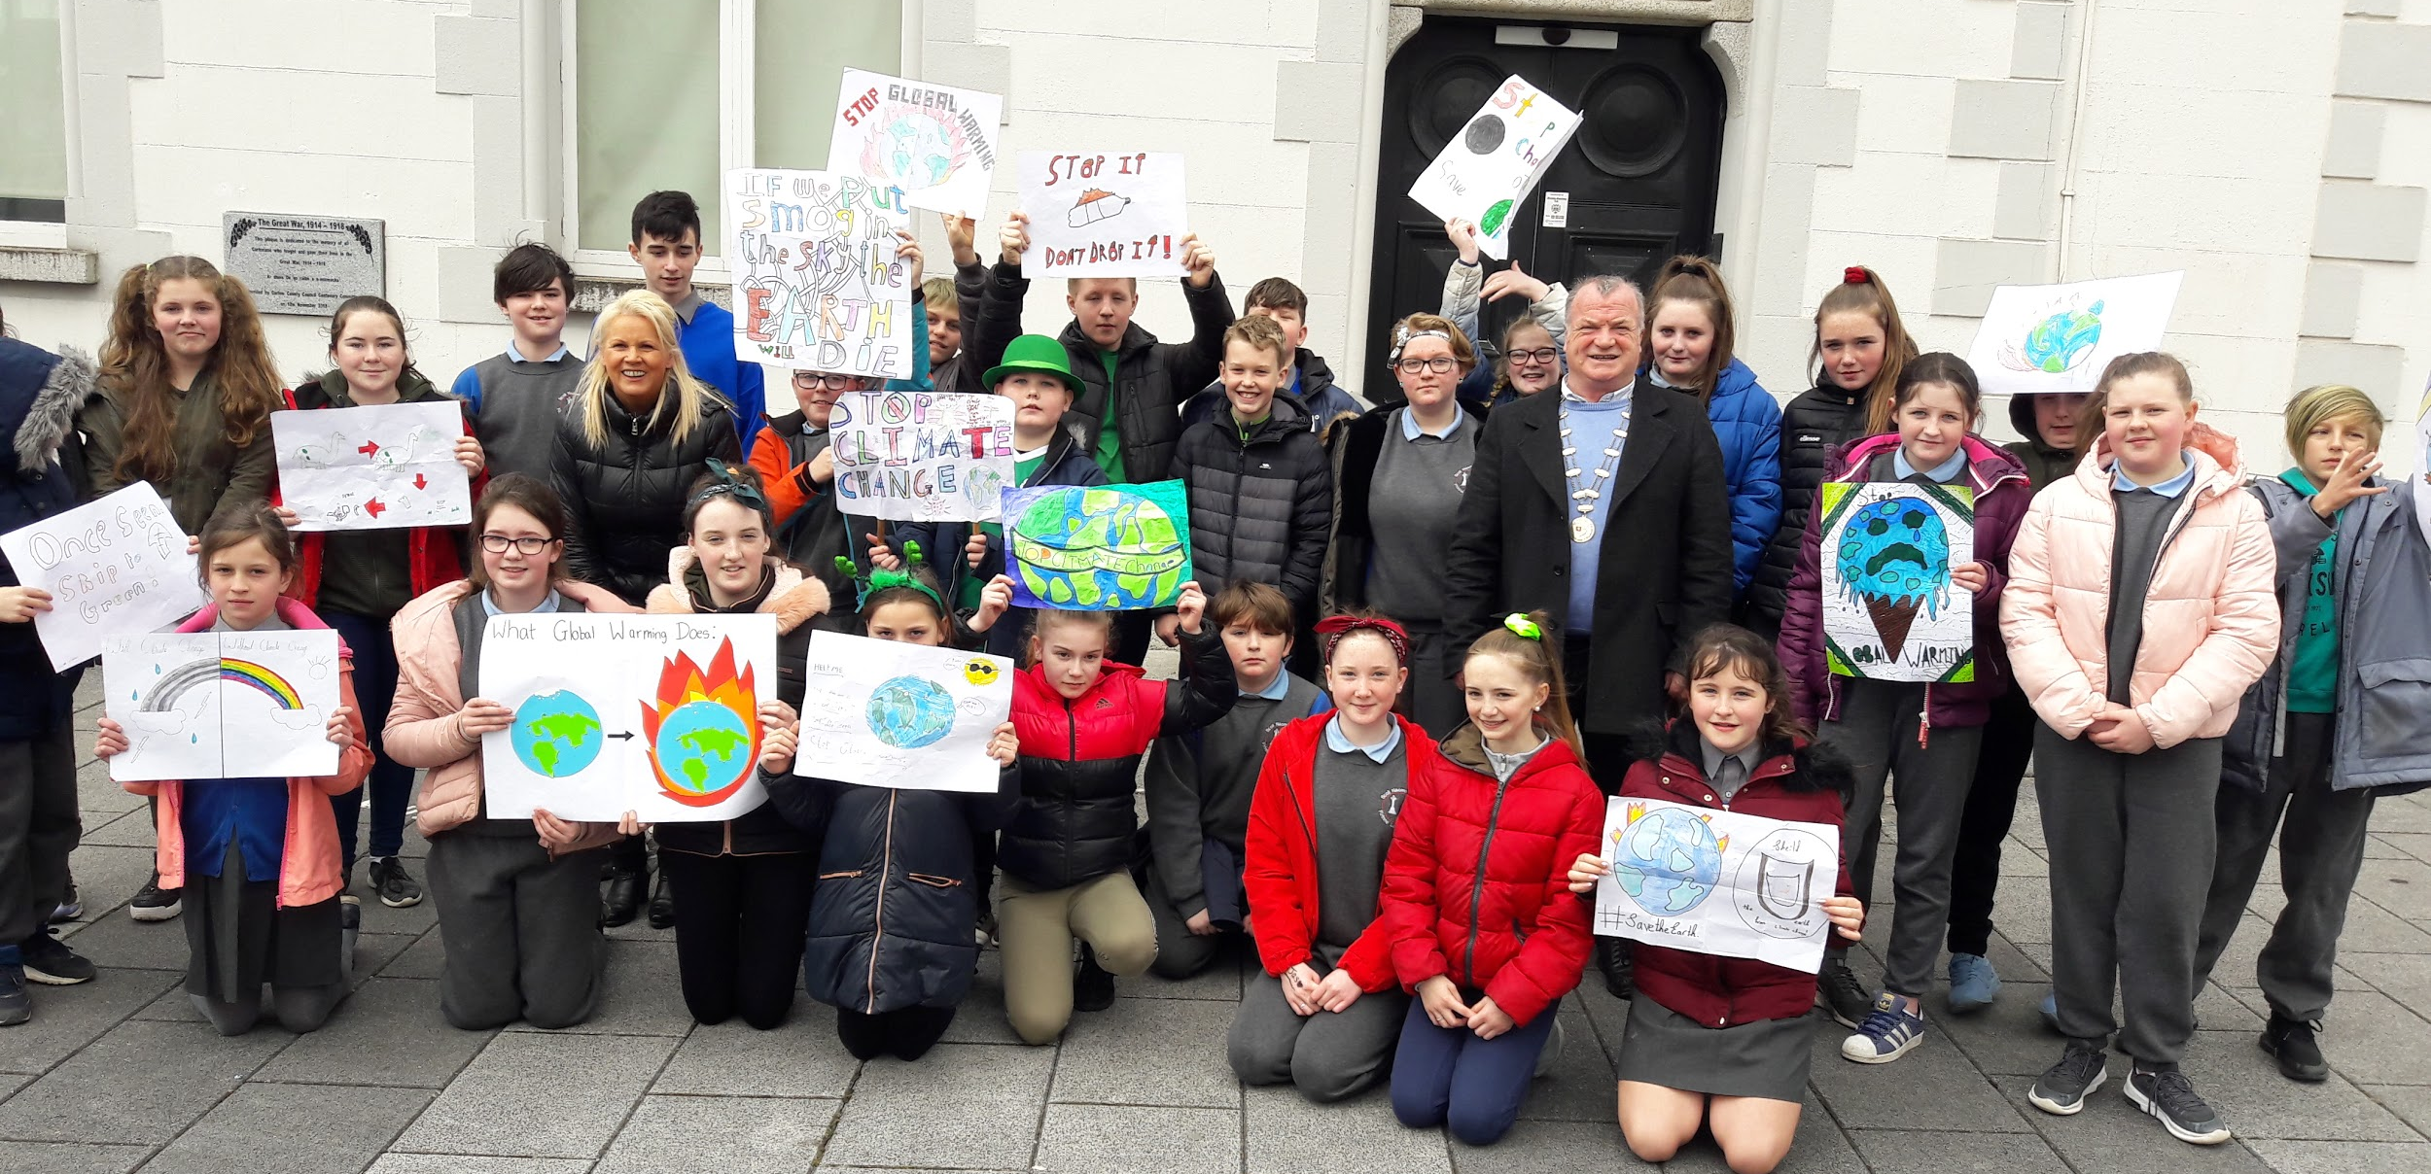

World Book Day at St. Fiacc’s

We are collecting stickers until April 5th!!! Aldi Rugby Competition 2019
As official supermarket of the IRFU, Aldi is giving primary schools the chance to win €50,000 to develop their playing facilities and help more kids live a healthy and active lifestyle.

